|  |  |
| --- | --- |
| A picture of a winding road and trees  New Century Wellness Group  Business System Analysis and Design | **RANDALL PETERSHEIM**  **MONTGOMERY COUNTY COMMUNITY COLLEGE**  **APRIL 23, 2017** |

Table of Contents

1 Table of Figures iii

2 Executive Summary 1

3 Systems Planning Phase 2

3.1 Introduction 2

3.2 New Century Wellness Group Business Profile 3

3.3 New Century Organizational Chart 4

3.4 Six Business Processes 5

3.5 Recommendations 5

3.6 Systems Development Method 6

3.7 Health Information Management Solutions 6

3.8 Preliminary Investigation 6

3.9 Feasibility Study 7

3.10 Preliminary Investigation Report 9

3.11 PowerPoint Presentation of Project Management Concepts 11

3.12 Key Project Management Terms 16

4 Systems Analysis Phase 17

4.1 Introduction 17

4.2 JAD Team Members 17

4.3 Systems Requirements Checklist 18

4.4 New Century Patient Satisfaction Survey 20

4.5 Sampling Method for Questionnaire 22

4.6 Data and Process Modeling 23

4.7 Proposed System Cost Overview 32

5 Systems Design Phase 40

5.1 Introduction 40

5.2 User Interface and User Experience 40

5.3 Data Design 46

5.4 System Architecture 49

6 Systems Implementation Phase 53

6.1 Introduction 53

6.2 Application Development Methods 53

6.3 Structure Charts 55

6.4 Testing Plan 58

6.5 Training 61

7 Appendix A: System Design Specification 64

7.1 Management Summary 64

7.2 System Components 65

7.3 System Environment 80

7.4 Implementation Requirements 83

7.5 Time and Cost Estimates 91

8 Appendix B: System Maintenance Issues 97

8.1 System Performance Memorandum 98

8.2 Ongoing Maintenance Memorandum 99

8.3 Security Risks Memorandum 101

# Table of Figures

Figure 1: New Century Wellness Center Organizational Chart 4

Figure 2: Continuation of Organization Chart 4

Figure 3: Data Flow Diagram – Context Diagram 23

Figure 4: Data Flow Diagram – Diagram 0 24

Figure 5: Diagram 1 – Appointment Processing 25

Figure 6: Diagram 2 – Payment and Insurance Processing 26

Figure 7: Diagram 3 – Reports Processing 27

Figure 8: Diagram 4 – Records Maintenance 28

Figure 9: Make New Appointment Use Case Diagram 30

Figure 10: Appointment Class Diagram 31

Figure 11: Appointment Sequence Diagram 31

Figure 12: State Transition States for Patient 31

Figure 13: Payback Analysis 36

Figure 14: Context Diagram for the New System 38

Figure 15: Diagram 0 for the New System 38

Figure 16: Main Screen Interface 40

Figure 17: Appointment Processing Interface 41

Figure 18: Payment and Insurance Processing Interface 41

Figure 19: Reports Processing Interface 42

Figure 20: Records Maintenance 42

Figure 21: Sample New Patient Entry Form 44

Figure 22: Example Entity-Relationship Diagram (ERD) 46

Figure 23: New Century Wellness Group Floor Plan 49

Figure 24: Diagram 0 Structure Chart 55

Figure 25: Diagram 1 Appointments Processing Module Structure Chart 56

Figure 26: Diagram 2 Payment and Insurance Processing Structure Chart 56

Figure 27: Diagram 3 Reports Processing Structure Chart 57

Figure 28: Diagram 4 Records Maintenance Structure Chart 57

# Executive Summary

New Century Wellness Group is a group of doctors providing preventative and traditional medicine in a holistic way. To better serve their patients, New Century Wellness Group has implemented a business software system that provides appointment scheduling, payment and insurance processing, reports processing and records maintenance. The system was designed and implemented using a structured application development process and was developed by RJP Consulting, LLC.

The first step in the analysis and design process was the systems planning phase. After gathering information about the organizational structure and business practices at New Century Wellness Group, it was recommended that a new business system be developed using structured application development. A preliminary investigation found that New Century Wellness Group would benefit from building a new business system or from buying a vertical software package that meets their requirements. These recommendations were found to operationally, economically, and technically feasible and could be completed in a reasonable amount of time. The findings were presented to New Century Wellness Group along with key project management concepts that would be needed.

The systems analysis phase involved finding the requirements for the new system and preparing an overview of what the new system should look like. A joint application development (JAD) team was formed which included all the office and medical staff, the managers and the systems analyst. This team was tasked with developing the requirements of the system. Additionally, a questionnaire was distributed to patients to find out how a new business system could better serve them. After the requirements were gathered, a system overview was proposed. A cost-benefit analysis was performed and the return on investment for a system developed in-house was estimated to be 201%.

In the system design phase, the user interface and database were designed. In the system implementation phase, a system architecture was developed that included the hardware and network requirements. The application was developed, tested, and deployed. Training was then provided for the users.

After a couple months of use, the employees of New Century Wellness Group were pleased with the efficiencies and usability of the system overall. However, it was noted that system performance and security were becoming an issue. It was recommended that New Century Wellness Group upgrade some of the database hardware and implement some security measures. Also, user requests for fixes and enhancements will be met by regular patches on an on-going basis.

# Systems Planning Phase

## Introduction

New Century Wellness Group anticipates continued growth and would like to update their existing record keeping systems to be more efficient and maintain accurate patient information. They currently use several computer systems for different business functions. They also have some functions on paper records. In the following document, RJP Consulting, LLC presents a plan to provide a new, integrated system that will meet New Century’s current and growing business needs.

As mentioned in the preliminary report, it is recommended that New Century hires a project manager as an outside consultant for the project. It is also recommended that they hire a full-time IT support person to support the deployment and provide ongoing support once the project is complete. The project manager will oversee finding and contracting an outside software development firm that specializes in the health care industry. The software company will design, develop and deploy the new, integrated system under the direction of the project manager.

## New Century Wellness Group Business Profile

Company Mission

We will provide quality preventative and traditional medicine to the greater Brea area with a focus on preventative medicine and fitness. In doing so, we will promote the wellness and fitness of the patients we serve.

Functions and services

1. Traditional medicine
2. Preventative medicine
3. Fitness
4. Physical therapy

Organization

See chart below

Suppliers

1. Pharmaceutical companies
2. Medical device companies
3. Office suppliers
4. Medical suppliers

Competitors

No direct competitors for the range of services provided.

Constraints

1. Applicable laws
2. Possible budget limitations – not discussed

Future Direction

Create an information system to support business and health information management needs

## New Century Organizational Chart

Figure 1: New Century Wellness Center Organizational Chart

Figure 2: Continuation of Organization Chart

## Six Business Processes

### Human resources and benefits management

Fred Brown handles human resources. Corrinne Summers reports to Fred. They need access to employee records and information from the companies that provide benefits for employees (health insurance, 401k, profit sharing). They need to provide benefit and tax information to employees.

### Patient medical records maintenance

Susan Gifford is responsible for this. She needs access to patient records and provides that information to the medical staff. She also gets information from the medical staff to update the records.

### Accounts receivable

Tom Capaletti handles accounts receivable. He needs information from the patient records about the services provided. He also needs information from patients for billing. He also needs information from insurance billing. He creates invoices and updates the records as accounts are paid.

### Insurance billing

Tammy Alipio needs patient records to know what to bill the insurance. She also needs insurance information from patients. She creates information for accounts receivable and for patients.

### Managing appointments

Lisa Sung manages appointments and needs availability information from the patients and the medical staff. She needs to know what procedures the patient needs from the medical staff.

### Ordering and organizing office and medical supplies

Carla Herrera organizes and orders office and medical supplies. She needs to know what is currently in inventory, what the staff needs, and where to order the supplies as well as pricing. She generates information on supply usage

## Recommendations

Based on the current information, I recommend a user productivity system to replace the current aging systems that are in place. The patient records system will use a transaction processing system that will have different modules available to medical staff and other modules available to the support staff. A separate transaction processing system will be needed for employee information and HR functions.

## Systems Development Method

I believe that a structured application development method would be best for this project because the system is too integrated to use an agile method. Also, because New Century is a medical services provider, it is subject to laws regarding patient records. A waterfall method would ensure that New Century is in compliance. Using an agile method could cause New Century to fall out of compliance while parts of the system are being deployed and the old systems are discontinued. The cons of using a waterfall development method are that the system will take quite a bit of time until it is deployed, employees will have an abrupt switch to the new system instead a gradual switch, and it will be harder to change the system if it doesn’t meet the requirements for a process.

## Health Information Management Solutions

* Electronic Medical Records (EMR) – According to HealtIT.gov, EMR are records for a patient that are kept by a single provider. They contain the patient’s history regarding that single provider.
* Electronic Health Records (EHR) – According to HealthIT.gov, EHR are records that cover a comprehensive view of a patient’s medical history. EHR are accessible across a wide range of providers and contain a more complete view of a patient’s medical history than EMR.
* Computerized Provider Order Entry (CPOE) – CPOE is a way for doctors to enter prescriptions for medication and prescriptions for other provider’s services in an electronic format. CPOE systems help reduce errors, but have a large cost to implement and train.
* Clinical Decision Support System (CDSS) – CDSS’s are systems that help providers make more informed decisions when diagnosing and treating patients. The systems help at the point when the provider is meeting with the patient and some data indicates that providers are more effective when using CDSS’s. Since the American Recover and Reinvestment Act of 2009, the use of CDSS’s have increased.

## Preliminary Investigation

1. Understand the problem

I plan to investigate to understand the root challenges associated with building an electronic medical records system at New Century. To do that I will build a business profile for current processes and determine who will be affected.

1. Define the project scope and constraints

I will define the project scope and restraints by creating a list of things that I must do, should do, could do, and won’t do. I will impose several restraints to curb project creep. Since we are dealing with health records, there are some external legal constraints that must be followed. I will determine which requirements are mandatory versus desirable and determine which ones need to be completed right away versus some time down the road.

1. Perform fact-finding

I will perform fact-finding by looking at organizational charts to determine who is responsible for what. I will then come up with a list of questions and conduct interviews with the employees that will be affected. I will review documentation that New Century currently has and documentation for EMR systems that are currently on the market as well as applicable regulations and best practices. I will estimate costs to implement a EMR system. I will also observe the day to day operations to get an idea what a system should look like. Then I will analyze the data.

1. Analyze project usability, cost, benefit and schedule data

The data from the fact-finding phase will be tabulated and put into a form that can more easily analyzed. The financial data will be looked and an overall financial and benefit fact sheet prepared. Also, the time needed to complete the project will be calculated.

1. Evaluate feasibility

Operational, technical, economic and schedule feasibility will be evaluated. Operational feasibility will be evaluated by seeing how the system will meet users’ needs. Technical feasibility will be evaluated by seeing what hardware and software requirements will be needed. Economic feasibility will be evaluated by seeing whether the benefits of the new system outweigh the costs needed to implement it. Schedule feasibility will look at how soon the system can be implemented with the available resources.

1. Present results and recommendations to management

A report of the preliminary investigation along with recommendations will be presented to Dr. Timothy Jones and Dr. Delores Garcia for them to review and for them to suggest a path forward.

## Feasibility Study

### Operational Feasibility

* Management supports the project
* Users may support the project if they are convinced it will help them
* It is unknown whether the current system is well liked and effectively used. Users see a need to change from paper records and have a more integrated system.
* The new system should not result in workplace reduction. Because the practice is growing, the current employees should be able to handle more capacity with a new system.
* The new system will require training for employees. New Century is prepared to provide time and resources to support training.
* The employees will be involved with planning the new system because user surveys and interviews will be used throughout the process.
* Performance and information accessibility will be enhanced by the new system, not decline. For example, inventory reports, will be able to be produced instantly without relying on additional user input.
* The patients may experience some slowdown in service while employees are being trained on the new system. However, because the new system will be more intuitive and adequate training provided, patients should not be negatively impacted.
* Implementing a new system should not harm New Century’s image, but care needs to be taken that the system meets the requirements and that adequate training is provided. If those things are not taken care of, patient care will be negatively affected which will harm the company’s image.
* The development schedule should not conflict with other priorities because the system will be developed using a waterfall method so users will switch after development and testing is complete.
* Laws regarding patient records need to be considered when planning the system. The system needs to have excellent security to protect the information and needs to comply with various laws regarding patient privacy, taxes, and employee rights.

### Economic Feasibility

* Because New Century does not have in-house IT staff, the development needs to be outsourced. Several bids will be obtained from software companies specializing in the health care industry. Additionally, it is recommended that New Century hires an on-site IT person to support the system and provide daily assistance and training to employees.
* The cost of the new workstations and servers need to be obtained from appropriate suppliers.
* The software company contracted to build the system needs to provide an estimate of immediate and ongoing costs for the system.
* Licensing and fees for maintaining the hardware and software needs to be tabulated.
* Consulting fees during development are summarized and billed to New Century.
* Additional space for the new servers needs to be allocated.
* A what-if analysis for not implementing the system was prepared.

### Technical Feasibility

* New Century does not have the necessary hardware, software or network resources. Vendors for these things exist and can be contracted easily.
* New Century does not have any IT staff. It is recommended that New Century contracts out the task of developing and implementing the software, and the task of deploying the new hardware. It is also recommended that they hire a full-time IT person to assist in deploying the system, training users and supporting the system in the future.
* The new system will be highly scalable and can support the growing New Century practice for years to come.
* A prototype will not be required.
* Because it is recommended that New Century updates its current workstations while updating the system, the system will be highly integrated. Additionally, the software company that builds the system will be one that specializes in building systems for health care providers and they will be selected for the ability to provide a stable and highly integrated solution.
* There are clear expectations for data and performance requirements that New Century currently uses and the new system will more than meet those requirements. The system will be very scalable and will provide room for the practice to grow.

### Schedule Feasibility

* The factors that influence schedule feasibility will be closely monitored by the consulting firm and efforts will be taken to mitigate changes in the schedule.
* Drs. Timothy Jones and Delores Garcia have not provided a clear timetable for the system to be complete.
* The system must be able to support employees in their current positions. The system must meet the required applicable legal standards, and the system must be able to be expanded and support more than one location.
* An accelerated schedule would pose risks because the project might not be able to determine the right requirements and because care needs to be taken to protect patients’ data and privacy.
* Project management techniques will be used to coordinate the project.
* A project manager will be appointed.

## Preliminary Investigation Report

### Introduction

The consulting group, RJP Consulting, LLC, performed a preliminary report on developing and deploying a new patients’ record and business system for New Century Wellness Group.

### Systems Request Summary

Dr. Timothy Jones and Dr. Delores Garcia would like to install a new computerized record keeping and business system at New Century Wellness Group to replace existing paper and computer records systems. They would like to support continued company growth and plan to open a new office on the other side of town. A new system would have to integrate a number of medical systems and a business record keeping systems. It would need to be scalable for future growth.

### Findings

It was found that an integrated system for patient records and business functions would be highly beneficial to New Century. A new system would integrate the functions that the medical staff does with patients on a daily basis with the scheduling and billing and supply maintenance that the support staff does on a daily basis. Such a system should be more user friendly and comply with applicable laws. This system will also be scalable to accommodate the growth that New Century anticipates.

### Recommendations

It is recommended that New Century should either build a new business system in-house, or buy a commercial software package that meets their requirements. If New Century chooses to buy from a vendor, they should choose a vendor that works in the health care industry. This vendor should develop a system to meet the requirements unique to New Century. Also, to assist in training employees to use the new system and supporting the new system in the long term, New Century should hire a qualified IT professional as a full-time employee. Alternatively, New Century could choose to build in-house by choosing RJP Consulting, LLC to build the system to their specifications.

### Project Roles

1. **Project Manager/Systems Analyst –** will plan and manage the project
2. **New IT Support Person –** will assist the project manager by providing training and on-site support
3. **Company that will develop and deploy the software -**  will investigate the requirements and develop and deploy the software
4. **Medical Staff and Support Staff –** will provide information about requirements and provide feedback as development proceeds

### Time and Cost Estimates

A quote will be provided by RJP Consulting, LLC for project management costs. Quotes will be obtained from software vendors, and a recruiting firm will be used to find a qualified IT support person.

The project will take approximately 18 months from start to finish.

### Expected Benefits

The software solution will provide an updated, modern interface for the medical and support staff to do their jobs. The software will be integrated, eliminating the need for paper records as well as extra data entry currently required to take data from one system and input it into the other systems.

## PowerPoint Presentation of Project Management Concepts

|  |
| --- |
|  |
|  |
|  |
|  |
|  |
|  |
|  |
|  |
|  |

## Key Project Management Terms

|  |  |
| --- | --- |
| **Concurrent Task** | A task that can be completed at the same time as other tasks.  Example: A developer can work on the UI while another is working a database. |
| **Critical Path** | The path on a PERT/CPM chart that shows the path of the tasks that need to be completed for the project to be completed on time. |
| **Critical Path Method** | A network diagram that shows the project as a network of tasks connected by dependencies. |
| **Event (or Milestone)** | A major occurrence in the life of a project  Example: All the design features of a website are complete |
| **Gantt Chart** | A calendar that displays the tasks of a project as a stack of horizontal bars. The dependencies of a task are represented by arrows from the predecessor task to the next task. |
| **Person-Day** | A measurement of the amount of time and number of people needed to complete a task. The number of people needed to complete the task are multiplied by how many hours they contribute.  Example: A server install could take two people one day to install resulting in two person-days. |
| **PERT/CPM Chart** | A PERT/CPM chart displays the tasks in boxes with arrows from box to box to indicate dependencies. |
| **Project Triangle** | Cost, scope and time are the three main factors that a project needs to effective. |
| **Risk Management** | The management of factors that could delay the project or cause it to fail.  Example: A key employee could leave the company in the middle of the project which would cause delays. This potential factor must be anticipated and a plan must be in place to proceed. |
| **Slack Time** | The extra time that tasks that are not on the critical path have to be completed.  Example: Someone must develop a dropdown menu for a website, but it is not on the critical path so there is more time available than needed to complete the task. |
| **Status Report** | A report made to management that shows the current status of the project or of a task within the project. |
| **Task** | Something someone does to further a project. A task has a defined starting point and ending point  Example: install a new printer on the network. |
| **Work Breakdown Structure** | A project that is broken down to individual tasks.  Example: Developing a website involves many different tasks from different people that need to be completed. |

# Systems Analysis Phase

## Introduction

After performing a preliminary investigation, it was recommended that a detailed analysis be performed on four key areas: patient scheduling, billing and accounts receivable, human resources, and payroll. A JAD team of the office staff and two medical staff persons was organized to provide input in creating the new system. A questionnaire for patients concerning insurance and appointment scheduling procedures was created for additional input. Additionally, data flow and use case diagrams were created as a logical model of the business transactions that occur at New Century Wellness Group. This logical model will later be used to create a systems model of the new software package.

The proposed system for New Century Wellness Group is a vertical software package that will be developed in-house. The five-year total cost of ownership is estimated to be $51,600 which includes consulting fees, a networked commercial package, network and hardware installation and ongoing maintenance. A cost-benefit analysis was done to showcase the difference between a system developed in-house and a system where the development was outsourced. An economic feasibility study was done on the proposed option as well as an outsourced option.

## JAD Team Members

1. **Office Staff**

Because New Century Wellness Group has less than ten people in the office staff, all of them should be part of the JAD team because each of them deals with a different part of the system and will have valuable input that would be missed if they were not on the team.

* 1. Anita Davenport – Office Manager

Anita can provide a high level overview of business functions and insight into new efficiencies.

* 1. Fred Brown – HR and Benefits

Fred can provide details about the current HR and benefits process and provide ways to make that system better.

* 1. Corrine Summers – Payroll, Taxes, and Profit Distribution

Corrine can provide details about payroll, taxes, and profit distribution and how a new system could provide easier access to those types of data.

* 1. Susan Gifford – Patient Medical Records (not part of the current development, but good to have to provide input for future integration)

Susan can provide information about the current state of the patient medical records system and can provide information about how the business system needs to interact with that system.

* 1. Tom Capaletti – Accounts Receivable

Tom can provide information and insight about how patients pay their bills and what sort of system would work best to make that easy for them.

* 1. Tammy Alipio – Insurance Billing Specialist

Tammy can provide information about how a business system can best interact with the various systems of the insurance companies.

* 1. Lisa Sung – Appointment Manager

Lisa can help to develop an efficient, user-friendly system to manage appointments.

* 1. Carla Herrera – Supplies Manager

Carla can provide insight to integrate supplies management into the new system.

1. **Medical Staff**

Because the current development will focus on patient scheduling, billing and accounts receivable, human resources and payroll, the medical staff will only be dealing with the new system tangentially. Not all of the medical staff will be needed on the JAD team, but it will be good to have on doctor and one nurse to provide input. Also, future development on a medical practice support system will be need to be integrated with the current development, it would be good for some of the medical staff be present when planning the new system.

* 1. One primary care physician
  2. One nurse

## Systems Requirements Checklist

1. Output Requirements
   1. The patient scheduling system must produce a daily schedule of appointments for each doctor, nurse practitioner, physical therapist and the nutritionist. It must also produce a daily list of patients that each nurse will be responsible for.
   2. The human resources system must produce a monthly report showing who is using PTO so that the managers can make sure that all systems are being covered when people take off.
   3. The accounts receivable system must produce bills each month for customers who haven’t paid.
   4. A supplies inventory report must be created weekly.
2. Input Requirements
   1. Medical staff must be able to input when they have met with a patient and what services they have performed.
   2. Staff must be able to input when they would like to take vacation.
   3. Medical and office staff must be able to input when they use supplies.
   4. Supplies manager must be able to input when they order supplies.
3. Process Requirements
   1. When supplies are low, the system must alert the supplies manager.
   2. The system must be able to alert the scheduling manager when a medical staff person goes over schedule with a patient, and the system must push back the next appointments.
   3. The scheduling system must not schedule appointments for medical staff when they are on PTO.
4. Performance Examples
   1. The scheduling system must produce a daily schedule for each of the medical staff before the beginning of the day.
   2. The systems must be available during business hours.
   3. The part of the system that interfaces with the medical staff must have a very quick response time.
5. Control Requirements
   1. The scheduling system must only allow access for the medical staff and the scheduling manager.
   2. The supplies manager should be the only person that can order supplies.
   3. Office staff should not be able to adjust medical supply inventory amounts.
   4. The payroll and benefits system should only be accessed by human resources.

## New Century Patient Satisfaction Survey

New Century Wellness Group is committed to improving our service. Below are some questions related to our insurance claims procedures and our scheduling procedures. Your responses will help us design an updated computer system for our staff. Please provide your most honest opinion and feel free to write additional comments at the bottom.

**All surveys are completely anonymous. Do not put your name or any identifiable information on this form.**

**Insurance Procedures**

1. How many times have you visited New Century Wellness Center in the past year?
   1. 1 to 2 times
   2. 3 to 5 times
   3. 6 or more times
2. Does New Century Wellness accept your insurance?
   1. Yes
   2. No
3. Out of the times you visited, how many times have you had a problem with an insurance claim?
   1. None
   2. Once
   3. 50% of the time
   4. 100% of the time
4. Does New Century Wellness provide all the services covered by your health insurance?
   1. Yes
   2. No
5. How interested would you be in using an online portal to see your visit summaries and insurance claims?
   1. Not interested
   2. Maybe
   3. Yes, I want to use an online portal
6. Do you have any suggestions for improving the insurance handling procedures at New Century Wellness Group?

**Patient Scheduling**

1. When you had a scheduled appointment, was the medical staff prompt for the appointment?
   1. Yes
   2. No
2. How interested would you be in seeing your appointments in an online portal?
   1. Not interested
   2. Maybe
   3. Yes, I want to use an online portal
3. How satisfied are you with the availability of appointments at New Century Wellness?
   1. Very unsatisfied
   2. Unsatisfied
   3. Neutral
   4. Satisfied
   5. Very satisfied
4. What suggestions do you have to improve the appointment scheduling process?

**Thanks for taking the time to take this survey!**

**Please give your completed survey to the person at the front desk before you leave.**

## Sampling Method for Questionnaire

The surveys will be handed out to all patients starting on Monday, March 20, 2017 and ending on Friday, March 31.

The survey forms will be handed to all patients as they check in along with a free pen. If the pens are returned, they must be disposed of immediately to prevent the spread of infections.

The office staff will tabulate the responses using an online survey form that will be provided. The paper copies will be shredded after processing. No identifying information should be entered into the online form.

## Data and Process Modeling

### Data Flow Diagrams

Data flow diagrams (DFDs) are diagrams that are used to represent different functional units of a system. DFDs are good when used with structured development and provide a foundation for developers to create programming modules. Below are the DFDs for the new system at New Century Wellness Group. The first diagram is called the context diagram and shows the system with outside entities and how they interact with the system. The next diagrams delve deeper into the system expanding on the previous diagrams. The lowest levels show functional primitives, or basic business transactions.

Figure 3: Data Flow Diagram – Context Diagram

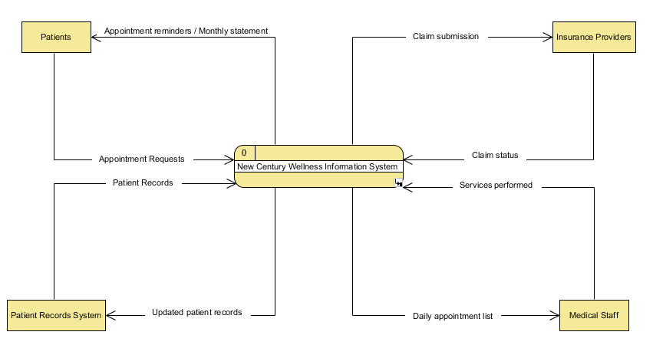

Figure 4: Data Flow Diagram – Diagram 0

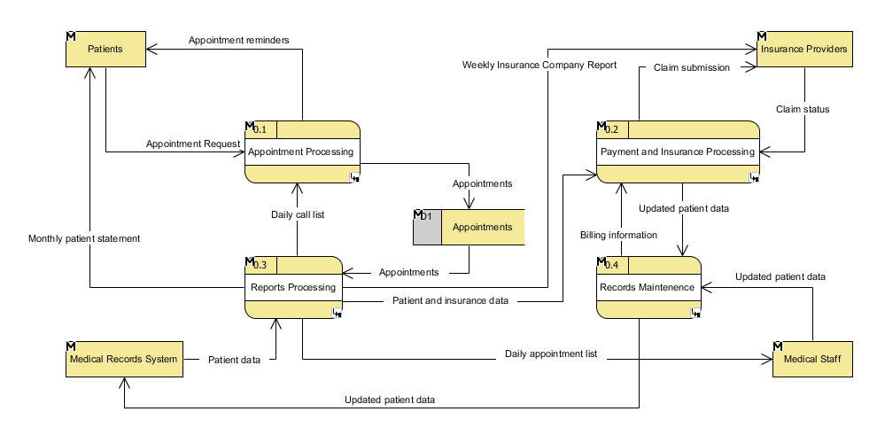

Figure 5: Diagram 1 – Appointment Processing

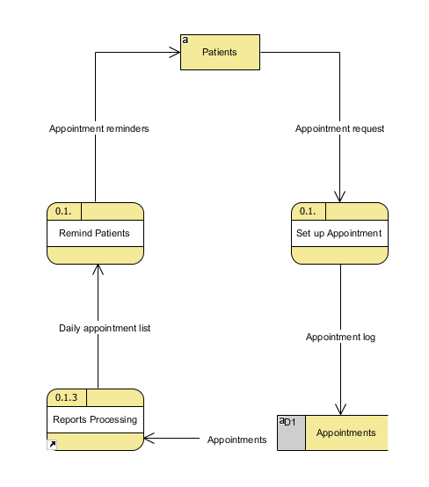

Figure 6: Diagram 2 – Payment and Insurance Processing

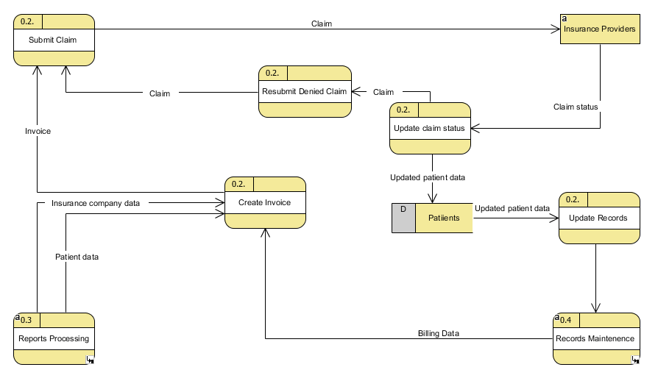

Figure 7: Diagram 3 – Reports Processing

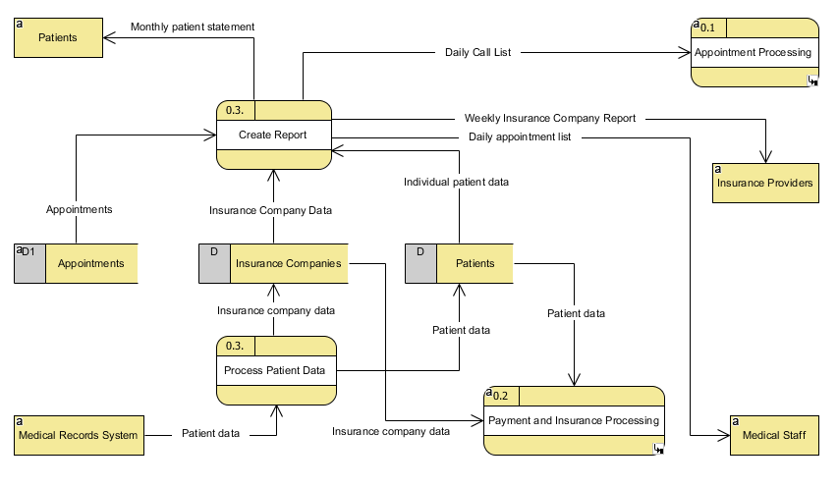

Figure 8: Diagram 4 – Records Maintenance

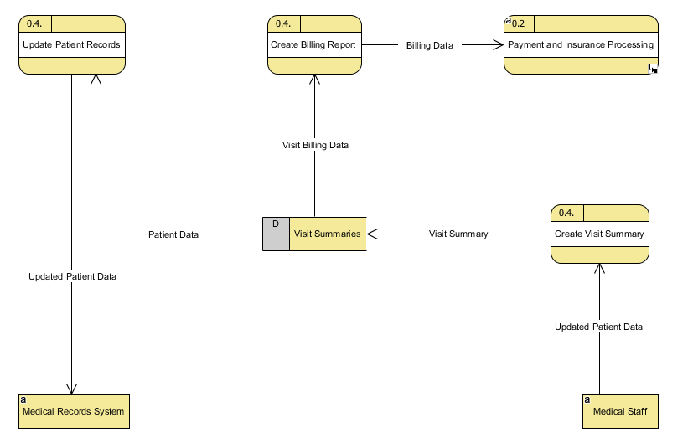

### Data Flows and Data Stores

Table 1: Data Flows and Data Stores

|  |  |  |
| --- | --- | --- |
| **Data Flows** | **Data Stores** | **Data Elements** |
| Appointment Log | Appointments | Patient Name |
| Appointment Reminders | Date |
| Appointment Request | Time |
| Appointments | Doctor |
| Billing Data | Insurance Companies | Name |
| Claim Status | Services Covered |
| Daily Appointment List | Contact Information |
| Daily Call List | Patients | Name |
| Individual Patient Data | Telephone Number |
| Insurance Company Data | Insurance Information |
| Invoice | Visit Summaries | Patient Name |
| Monthly Patient Statement | Date |
| Patient Data | Time |
| Updated Patient Data | Services Performed |
| Visit Billing Data | Cost |
| Visit Summary |  |  |
| Weekly Insurance Company Report |  |  |

Table 2: Dictionary Entry Examplee

|  |  |
| --- | --- |
| **Label** | REMIND PATIENTS |
| **Entry Type** | PROCESS |
| **Description** | Remind patients of upcoming appointments |
| **Process #** | 0.1.1 |
| **Process Description** | Input data flows: DAILY APPOINTMENT LIST  Output data flows: APPOINTMENT REMINDERS  For each item on DAILY APPOINTMENT LIST  Call Patient Number  If Patient Answers  Remind Patient of Appointment  Else if answering machine  Leave a message  Else  Call back later |

### Object-Oriented Diagrams

Object-oriented analysis is a way to represent a system by representing things as objects. An object could be a person, event, or transaction. The system is represented by interaction between objects. Each object has attributes which characterize the object. Objects also have methods which are actions the object can perform. Object-oriented analysis is good when used with an object-oriented programming language. Below is a use case diagram for New Century Wellness Group.

Table 3: Possible Use Cases for New Century Wellness Group

|  |  |  |
| --- | --- | --- |
|  | **Use Case** | **Actor** |
| **1.** | Make New Appointment | Patient  Appointment Manager |
| **2.** | Remind Patient of Appointment | Appointment Manager  Patient |
| **3.** | Send Claim to Insurance Company | Insurance Billing Specialist  Insurance Company |

Figure 9: Make New Appointment Use Case Diagram

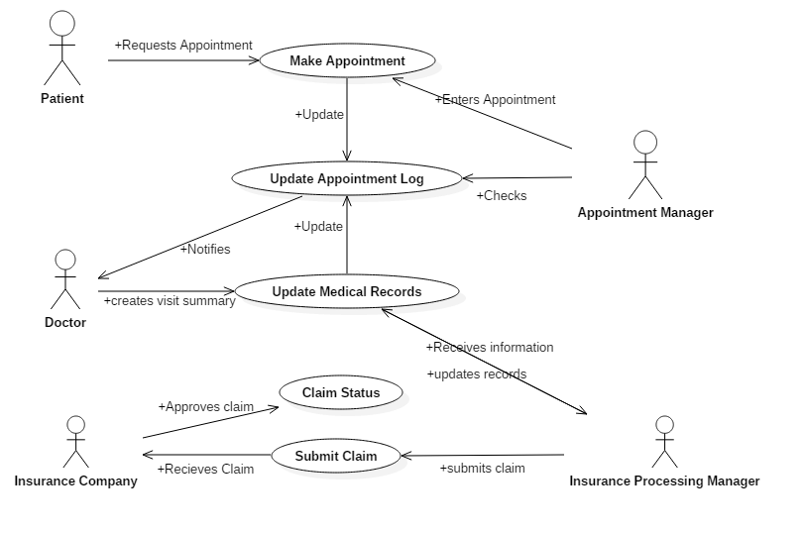

Figure 10: Appointment Class Diagram

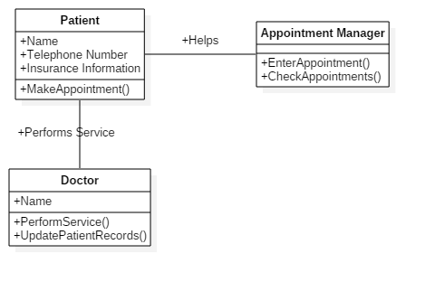

Figure 11: Appointment Sequence Diagram

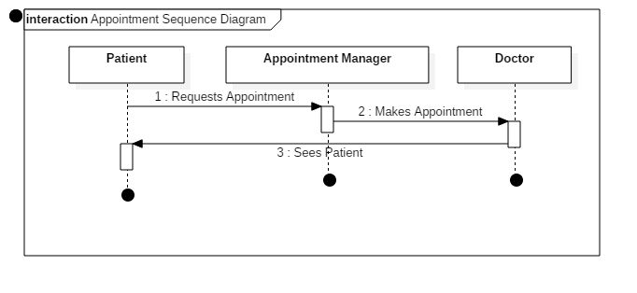

Figure 12: State Transition States for Patient

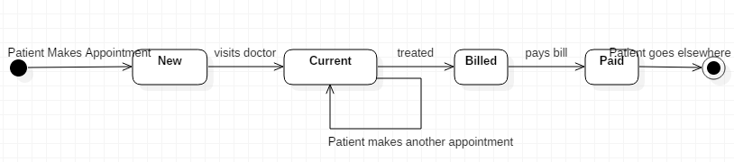

## Proposed System Cost Overview

The proposed system cost overview below shows the costs of several different options including keeping the current system. A cost-benefit analysis was performed and return on investment calculated along with the present value. The costs shown below are estimations based on the information provided by New Century Wellness Group as well as estimations of various commercially available software and hardware packages. These costs are estimations only and subject to change at any time.

### Costs

1. **In-house Option**

The five-year cost of ownership to develop the new system in-house will be $51,600. That figure includes consulting fees, a networked commercial package, network and hardware installation, and ongoing maintenance.

Table 4: Five Year Total Cost of Ownership for In-house Option

|  |  |  |
| --- | --- | --- |
| In-house Option (1st year) | Consulting Fee (480 hours at $35/hour) | 16800 |
|  | Networked Commercial Package | 2500 |
|  | Network and Hardware Installation | 12500 |
|  | Ongoing Consulting Fee (120 hours) | 4200 |
|  | Cost of maintenance | 3120 |
|  | **Total** | **$39120** |
|  |  |  |
| Ongoing Costs (2nd year) | Cost of maintenance ($) | 3120 |
|  | **Total** | **$3120** |
|  |  |  |
| Ongoing Costs (3rd year) | Cost of maintenance ($) | 3120 |
|  | **Total** | **$3120** |
|  |  |  |
| Ongoing Costs (4th year) | Cost of maintenance ($) | 3120 |
|  | **Total** | **$3120** |
|  |  |  |
| Ongoing Costs (5th year) | Cost of maintenance ($) | 3120 |
|  | **Total** | **$3120** |
|  |  |  |
| Five Year Cost of Ownership |  | $51600 |

1. **Outsource Option**

The five-year cost of ownership to outsource the systems development will be $52,200. That figure also includes consulting fees, a vertical software package, network and hardware installation, ongoing maintenance, and technical support.

Table 5: Five Year Total Cost of Ownership for Out-sourced Option

|  |  |  |
| --- | --- | --- |
| In-house Option (1st year) | Consulting Fee (160 hours at $35/hour) | 5600 |
|  | Vertical Software Package | 4000 |
|  | Network and Hardware Installation | 12500 |
|  | Ongoing Consulting Fee (120 hours) | 4200 |
|  | Cost of maintenance | 3120 |
|  | **Total** | **$29420** |
|  |  |  |
| Ongoing Costs (2nd year) | Software Package Payment | 4000 |
|  | Cost of maintenance | 3120 |
|  | Technical Support Agreement | 600 |
|  | **Total** | **$7720** |
|  |  |  |
| Ongoing Costs (3rd year) | Software Package Payment | 4000 |
|  | Cost of maintenance | 3120 |
|  | Technical Support Agreement | 600 |
|  | **Total** | **$7720** |
|  |  |  |
| Ongoing Costs (4th year) | Cost of maintenance | 3120 |
|  | Technical Support Agreement | 600 |
|  | **Total** | **$3720** |
|  |  |  |
| Ongoing Costs (5th year) | Cost of maintenance | 3120 |
|  | Technical Support Agreement | 600 |
|  | **Total** | **$3720** |
|  |  |  |
| Five Year Cost of Ownership |  | **$51600** |

1. **Current Option**

The five-year cost of ownership to keep the current system at New Century Wellness Group is $195,000. That figure includes hiring a new office staff member, the cost of fixing errors, and the ongoing maintenance of the current system.

Table 6: Five Year Total Cost of Ownership for Current Option

|  |  |  |
| --- | --- | --- |
| In-house Option (1st year) | Cost of maintenance | 7020 |
|  | New Office Staff Member Cost | 15600 |
|  | Cost of errors | 3900 |
|  | **Total** | **$26520** |
|  |  |  |
| Ongoing Costs (2nd year) | Cost of maintenance | 7020 |
|  | New Office Staff Member Cost | 31200 |
|  | Cost of errors | 3900 |
|  | **Total** | **$42120** |
|  |  |  |
| Ongoing Costs (3rd year) | Cost of maintenance | 7020 |
|  | New Office Staff Member Cost | 31200 |
|  | Cost of errors | 3900 |
|  | **Total** | **$42120** |
|  |  |  |
| Ongoing Costs (4th year) | Cost of maintenance | 7020 |
|  | New Office Staff Member Cost | 31200 |
|  | Cost of errors | 3900 |
|  | **Total** | **$42120** |
|  |  |  |
| Ongoing Costs (5th year) | Cost of maintenance | 7020 |
|  | New Office Staff Member Cost | 31200 |
|  | Cost of errors | 3900 |
|  | **Total** | **$42120** |
|  |  |  |
| Five Year Cost of Ownership |  | **$195000** |

1. **Benefits**
   1. **In-house Option**

The benefits of developing a software system in-house include the ability to customize the software to the exact requirements of New Century Wellness Group, not having to pay a technical support fee every year, and a slight decrease from the cost of out-sourcing. A disadvantage of developing a new system in-house is that it may take more time than what an outsourced system would be.

* 1. **Outsource Option**

The benefits of outsourcing the development of the new system include ongoing technical support, less headache in designing the system and peace of mind that comes from a system that is already being used by similar companies. A disadvantage of outsourcing is that the system may not be as customizable as a system developed in-house.

* 1. **Current Option**

There are no benefits to keeping the current system. Having to add another office staff person adds a significant cost as well as the cost of correcting errors and significantly higher maintenance costs than what would be needed for the new system.

* 1. **Table of Benefits for In-House or Outsource Option**

Table 7: Benefits Types

|  |  |  |
| --- | --- | --- |
| **Benefit** | **Type** | **Benefit Amount** |
| Not having to hire new employee | Cost-avoidance | $140,400 (4.5 years) |
| Growth Benefit | Postive | $15,000 (5 years) |
| **Total** | | **$155,400** |

Table 8: Benefit Yearly Amounts

|  |  |  |  |  |  |
| --- | --- | --- | --- | --- | --- |
| **Benefit** | **Year 1** | **Year 2** | **Year 3** | **Year 4** | **Year 5** |
| Not having to hire new employee | $15,600 | $31,200 | $31,200 | $31,200 | $31,200 |
| Growth Benefit | $3000 | $3000 | $3000 | $3000 | $3000 |
| Total | $18,600 | $34,200 | $34,200 | $34,200 | $34,200 |

1. **Cost Benefit Types and Categories**
   1. **Maintenance Costs –** Costs to maintain the systems so that they function properly.
   2. **Consulting Fees –** Fees to consulting firm to oversee the systems analysis, design, and implementation phases.
   3. **Software Purchase -**Costs to purchase and implement software packages.
   4. **Network and Equipment Upgrades –** Costs to upgrade network and server equipment to support and host the new software systems. Newer hardware is more secure and faster than current hardware.
   5. **Personnel Requirements –** Costs to hire new office staff member to support current system if no change is made to the system.
   6. **Ongoing Costs –** Costs of technical support and maintenance that will ensure continued optimal functioning of the systems.

### Economic Feasibility Analysis

1. **Payback Analysis**

Figure 13: Payback Analysis

1. **Return on Investment**

Table 9: Return on Investment (ROI)

|  |  |  |  |
| --- | --- | --- | --- |
| **Option** | **Total Cost** | **Total Benefit** | **Return on Investment (ROI)** |
| In-House | $51,600 | $155,400 | 201% |
| Outsourced | $52,300 | $155,400 | 197% |

1. **Present Value**

Table 10: Present Value for In-House Option

|  |  |  |  |  |  |  |
| --- | --- | --- | --- | --- | --- | --- |
|  | **Year 0** | **Year 1** | **Year 2** | **Year 3** | **Year 4** | **Total** |
| **Benefits** | 18600 | 34200 | 34200 | 34200 | 34200 |  |
| **Factor** | 0.909 | 0.826 | 0.751 | 0.683 | 0.621 |  |
| **PV of Benefits** | 16907 | 28249 | 25684 | 23359 | 21238 | $115,438 |
|  |  |  |  |  |  |  |
| **Costs** | 39120 | 3120 | 3120 | 3120 | 3120 |  |
| **Factor** | 0.909 | 0.826 | 0.751 | 0.683 | 0.621 |  |
| **PV of Costs** | 35560 | 2577 | 2343 | 2131 | 1938 | $44,549 |
|  |  |  |  |  |  |  |
|  |  |  | **Net Present Value** | | | **$70,889** |

Table 11: Present Value for Outsourced Option

|  |  |  |  |  |  |  |
| --- | --- | --- | --- | --- | --- | --- |
|  | **Year 0** | **Year 1** | **Year 2** | **Year 3** | **Year 4** |  |
| **Benefits** | 18600 | 34200 | 34200 | 34200 | 34200 |  |
| **Factor** | 0.909 | 0.826 | 0.751 | 0.683 | 0.621 |  |
| **PV of Benefits** | 16907 | 28249 | 25684 | 23359 | 21238 | $115,438 |
|  |  |  |  |  |  |  |
| **Costs** | 29420 | 7720 | 7720 | 3720 | 3720 |  |
| **Factor** | 0.909 | 0.826 | 0.751 | 0.683 | 0.621 |  |
| **PV of Costs** | 26743 | 6377 | 5798 | 2541 | 2310 | $43,768 |
|  |  |  |  |  |  |  |
|  |  |  | **Net Present Value** | | | **$71,670** |

### Context Diagram and Diagram 0 for the New System

Figure 14: Context Diagram for the New System



Figure 15: Diagram 0 for the New System



### Explanation of Various Alternatives

1. **In-house Development**

In-house development is an option for New Century Wellness Group. However, the cost is very similar to buying a vertical package with the added risk of not having a technical support contract.

1. **Other Possible Strategies**

Other possible strategies include sticking with the current system. However, as shown in the economic feasibility analysis, sticking with the current system incurs very high costs due to having to hire another person on the office staff as well as the cost of correcting errors in the current system.

# Systems Design Phase

## Introduction

The proposed system for New Century Wellness Group is a vertical software package that will be developed in-house. The five-year total cost of ownership is estimated to be $51,600 which includes consulting fees, a networked commercial package, network and hardware installation and ongoing maintenance. A cost-benefit analysis was done to showcase the difference between a system developed in-house and a system where the development was outsourced. An economic feasibility study was done on the proposed option as well as an outsourced option. A sample user interface screens and example data tables were created to showcase the user interface and how data will be stored in the database.

## User Interface and User Experience

### User Interface

Figure 16: Main Screen Interface

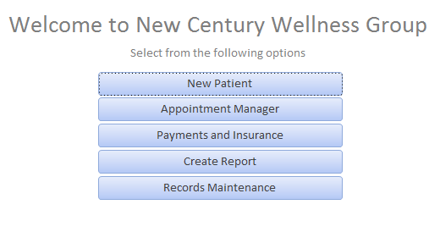

Figure 17: Appointment Processing Interface

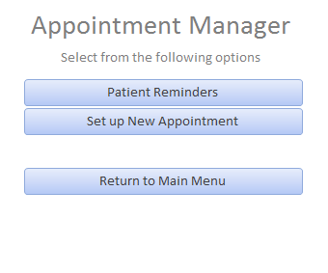

Figure 18: Payment and Insurance Processing Interface

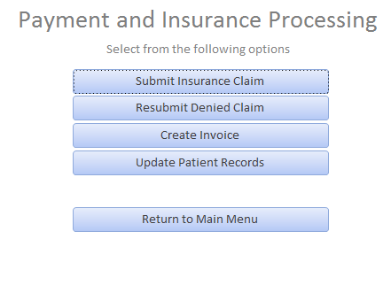

Figure 19: Reports Processing Interface

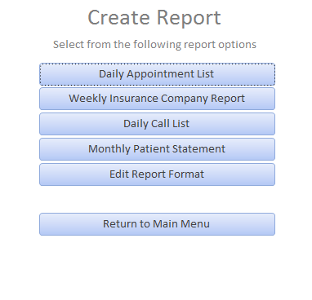

Figure 20: Records Maintenance

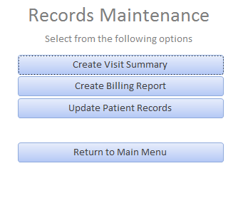

### Sample Data Entry Form

Table 12: Data Required for New Patient Form

|  |
| --- |
| Last Name |
| First Name |
| SSN |
| Gender |
| Marital Status |
| Address |
| City |
| State |
| Postal Code |
| Phone Number |
| Smoker |
| Alcohol |
| Drugs |
| Exercise |
| Medical Conditions |
| Allergies |
| Insurance Company |

Figure 21: Sample New Patient Entry Form

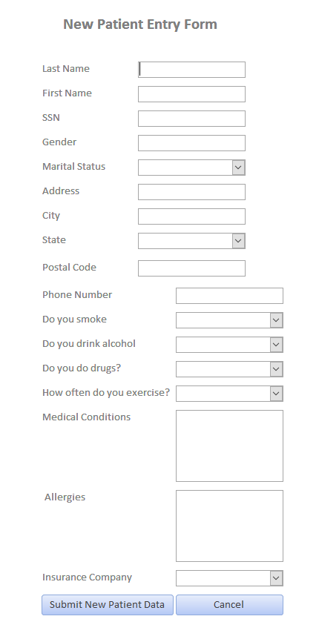

### Control Features

Table 13: Example Control Features to be Used in Forms

|  |  |  |
| --- | --- | --- |
| **Input** | **Control Features** | **Example** |
| Last Name | Text and dashes only  Check to see if name is already in system | Rivera-Martinez |
| Street Address | Number plus street name  Use map service to validate address | 123 Main St. |
| City | Text only | Lancaster |
| State | Dropdown of two character postal codes | PA |
| Zip Code | 5 digits plus 4 digits optional  Use map service to validate address | 17999 (+1234) |
| Telephone Number | Three-digit area code plus seven digit number | (929) 123-4567 |
| Insurance Company Name | Dropdown of list of insurance companies | Highmark |

### Possible Output Technologies that New Century Wellness Group Could Implement

1. **Printed Reports**

Printed reports could include appointment lists for doctors, patient appointment call lists for the appointment manager, and monthly patient statements to be sent to patients. Printed reports are important for people who don’t have access to online systems or for certain office/medical staff applications.

1. **Internet Patient Portal**

An internet patient portal would be helpful for patients to schedule and view appointments, view medical records and view insurance and billing information.

1. **Email/Text Appointment Reminders**

Email and text appointment reminders would be a good way to remind patients of appointments that could be used in addition to the telephone reminder. Allowing patients to opt-in or opt-out will reduce the impression that New Century Wellness Group is spamming them.

1. **Internal Medical Records Portal for Doctors and Nurses**

Having medical records available in an online portal for doctors and nurses will be very helpful so that paper records are not lost or damaged.

1. **Internal Employee Benefits Portal**

An internal employee benefits portal will allow employees to view insurance, 401(k), and general HR information.

## Data Design

### Entity-Relationship Diagram

Figure 22: Example Entity-Relationship Diagram (ERD)

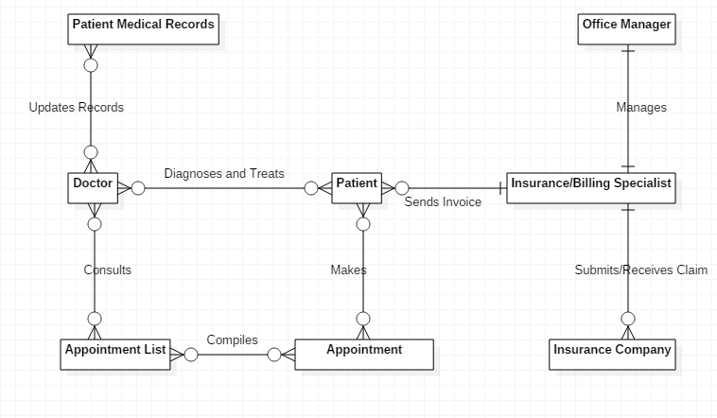

Table 14: ERD Relationships

|  |  |  |
| --- | --- | --- |
| **First Entity** | **Second Entity** | **Relationship** |
| Patient Medical Records | Doctor | M:N |
| Doctor | Appointment List | M:N |
| Doctor | Patient | M:N |
| Appointment | Patient | M:N |
| Patient | Insurance/Billing Specialist | M:1 |
| Office Manager | Insurance/Billing Specialist | 1:1 |
| Insurance/Billing Specialist | Insurance Company | 1:M |

### Example Database Tables

Table 15: Example Database Table for Patients

|  |  |  |  |
| --- | --- | --- | --- |
| **Patient Number**  **(5 digit number)**  **PK** | **Patient Name**  **(String)** | **Telephone Number**  **(9 digit number)** | **Insurance Compnay Number**  **(2 digit number)**  **FK** |
| 12999 | Laura Smith | 584-585-7895 | 55 |
| 23233 | Paul Bunyon | 879-8795265 | 46 |
| 33999 | Luke Sky | 657-804-5578 | 87 |

Table 16: Example Database Table for Doctors

|  |  |
| --- | --- |
| **Doctor Number**  **(2 digit number)**  **PK** | **Doctor Name** |
| 55 | Rivera |
| 33 | Hedgeh |
| 25 | Vader |

Table 17: Example Database Table for Appointments

|  |  |  |  |  |
| --- | --- | --- | --- | --- |
| **Appointment Number**  **(5 digit number)**  **PK** | **Appointment Date**  **(Date)** | **Appointment Time**  **(Time)** | **Doctor Number**  **(2 digit number)**  **FK** | **Patient Number**  **(5 digit number)**  **FK** |
| 34353 | 19-Apr | 4:20PM | 33 | 23233 |
| 35354 | 1-May | 5:30PM | 55 | 12999 |
| 22345 | 5-May | 9:00AM | 25 | 33999 |

### Updated Data Stores and Data Flows

Table 18: Updated Data Flows and Data Stores

|  |  |  |  |
| --- | --- | --- | --- |
| **Data Stores** | **Data Elements** | **Key** | **Data Type** |
| Appointments | Appointment Number | Primary Key | 5-digit number |
| Date |  | Date |
| Time |  | Time |
| Doctor Number | Foreign Key | 2-digit number |
| Patient Number | Foreign Key | 5-digit number |
| Insurance Companies | Insurance Company Number | Primary Key | 2-digit number |
| Insurance Company Name |  | String |
| Services Covered |  | List |
| Contact Information |  | 9-digit number |
| Patients | Patient Number | Primary Key | 5-digit number |
| Patient Name |  | String |
| Telephone Number |  | 9-digit number |
| Insurance Company Number | Foreign Key | 2-digit number |
| Visit Summaries | Visit Number | Primary Key | 5 digit number |
| Patient Number | Foreign Key | 5-digit number |
| Doctor Number | Foreign Key | 2-digit number |
| Date |  | Date |
| Time |  | Time |
| Services Performed |  | List |
| Cost |  | Currency (USD) |

## System Architecture

### Floor Plan

Figure 23: New Century Wellness Group Floor Plan

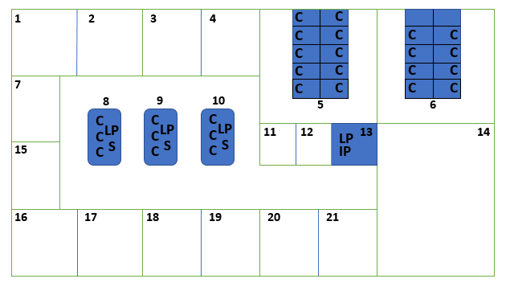

Table 19: Hardware and Network Requirements

|  |  |  |  |  |
| --- | --- | --- | --- | --- |
| Room ID | Description | Equipment Currently Needed | Equipment Needed in the Future | Number of Ports |
| 1 | Exam Room 1 |  | Workstation or thin client | 3 |
| 2 | Exam Room 2 |  | Workstation or thin client | 3 |
| 3 | Exam Room 3 |  | Workstation or thin client | 3 |
| 4 | Exam Room 4 |  | Workstation or thin client | 3 |
| 5 | Medical Staff Cubicle Area | 1 Switch  10 workstations |  | 1 in  10 out |
| 6 | Office Staff Cubicle Area  (Extra cubicles for future expansion) | 1 Switch  8 Workstations |  | 1 in  10 out |
| 7 | Server/IT Equipment Room | 1 Gateway servers  2 Wireless Access Points  1 Wired Router |  | 1 cable/fiber port in  38 ports out |
| 8 | Nurse Station 1 | 1 Switch  3 Workstations  1 Laser Printer  1 Scanner |  | 1 in  3 out |
| 9 | Nurse Station 2 | 1 Switch  3 Workstations  1 Laser Printer  1 Scanner |  | 1 in  3 out |
| 10 | Nurse Station 3 | 1 Switch  3 Workstations  1 Laser Printer  1 Scanner |  | 1 in  3 out |
| 11 | Women’s Bathroom |  |  |  |
| 12 | Men’s Bathroom |  |  |  |
| 13 | Check-in/Check-out Station | 1 Switch  Possible Workstation (not specified)  1 Laser Printer  1 Impact Printer |  | 1 in  3 out |
| 14 | Waiting Area |  | Possible entertainment center | 1 |
| 15 | Supplies Room |  | Possible Inventory Control System | 1 |
| 16 | Exam Room 5 |  | Workstation or thin client | 3 |
| 17 | Exam Room 6 |  | Workstation or thin client | 3 |
| 18 | Exam Room 7 |  | Workstation or thin client | 3 |
| 19 | Exam Room 8 |  | Workstation or thin client | 3 |
| 20 | Exam Room 9 |  | Workstation or thin client | 3 |
| 21 | Exam Room 10 |  | Workstation or thin client | 3 |

### Physical and Logical Network Topologies

Network topologies refer to the physical and logical structure of the network. A number of different logical topologies exist including hierarchical, bus, ring, star, and mesh networks, as well as wireless networks. The most common network today is the star topology using switches connected to network devices with ethernet cables. One ethernet cable connects one device (workstation or printer) to a switch. Switches can be daisy chained to reduce the amount of ethernet cabling needed. The advantage of using a star network is the degree of control. A disadvantage would be the outage that would occur when a switch went down. This can be mitigated with redundant switches.

It is recommended that New Century Wellness Group use the star topology with the following configuration.

The Internet gateway, servers, and main switch will be located in the Server/IT Equipment Room. A total of 38 ethernet cables will come out of the server room and be routed through the ceiling and down into the walls where there will be a wall mounted ethernet outlet.

Each exam room will have 3 ethernet connections. In the new system, there is no need for any connectivity in the exam rooms, but the electronic medical record phase of the project requires a workstation or thin client in each exam room. Adding 3 ethernet outlets for each exam room allows for connectivity for future medical equipment that may require network connectivity. Adding the extra cables now is negligibly more expensive compared to a high expense later. Also the supply room will have an ethernet outlet in case the room is repurposed in the future, or a networked inventory control system is added.

Each nursing station will have one ethernet cable going to it, and a 4 port ethernet switch installed to accommodate the 3 workstations. One of the workstations will have a laser printer and scanner installed locally so the printer and scanner will not require network connectivity.

The medical staff cubical area will have one ethernet cable going to it with a switch with at least 10 ports on it. More ports are preferred to accommodate future expansion. Again, having one ethernet cable connected to a switch reduces the cabling required from the Server/IT Equipment Room.

Likewise, the office cubical area will have the same configuration as the medical staff. However, there are only 8 workstations currently needed.

The check-in/check-out station will also have one ethernet cable with a switch to accommodate 2 networked printers and a possible workstation.

### Wireless Network

A wireless network will be required in the future to accommodate the electronic medical records system which requires portable computers and tablets for the medical staff. Wireless networks are very useful for mobile devices, but can have connectivity issues for critical systems and have inherently less security than a wired network. If a wireless network is desired for guest access, it should be a separate system from the one for the electronic medical records system.

# Systems Implementation Phase

## Introduction

The system implementation phase includes installing the hardware, building the application, testing, deployment and training. As mentioned previously, structured application development will be used which has three phases: planning, development and testing. A testing plan was created along with sample data. Finally, a training plan was developed. A system design specification was also created and can be found in Appendix B. This system design specification includes relevant material from entirety of this document.

## Application Development Methods

My team will use structured application development for the new system at New Century Wellness Center. Structured development will allow the system to be completely designed, coded and tested before deployment. This will allow us to make sure the system works and will keep the critical systems running at New Century Wellness that are currently in place.

The steps of structured application development are explained below.

1. Planning – The system has already been planned and designed. We used employee interviews, questionnaires and other ways to determine how the current system works, system requirements for the new system, and the database and hardware requirements. A new system has been designed that will meet the requirements of New Century Wellness Group.
2. Development – This phase will include coding the different modules needed for the new system. This includes design, code, test and documentation modules. The design will be based on the data flow diagrams that were developed previously.
3. Testing – Testing includes integration testing, system testing and documentation. Integration testing is taking the individual modules that were developed and making sure that they work well together. System testing is testing the entire system once it is installed and configured. That includes testing the hardware, the network and making sure all of the logical and physical components are doing their job. An example would be testing the printers to make sure the reports from the software are printing properly on the new network printers.

The system development tools that my team will use are explained below. These tools will help us design and develop a system that will meet the requirements of New Century Wellness Group.

1. Data Flow Diagrams – DFDs are a type of diagram that show how data flows to and from different entities and process in a system. The DFDs for the new system can be found in Section 4.5.
2. Entity-Relationship Diagrams – ER diagrams show relationships among the various entities and objects in the system. The relationship between entities and objects can be one-to-one, one-to-many, and many-to-many. An example of one-to-many is the relationship between one doctor and many patients. An example of a one-to-one relationship is the relationship between the office manager and the individual office staff members.
3. Flowcharts – Flowcharts are used to show program logic and rules in a graphical form. They help programmers break large processes down into smaller processes that can be programmed efficiently.
4. Pseudocode – Pseudocode is used to translate a primitive business function into simple English statements that represent programming steps. Pseudocode is a good intermediate between the design for the new system and the code that will be compiled into the new system.
5. Decision Tables and Decision Trees – These are used to show how business logic works in the new system. A decision tree shows the outcomes of a series of decisions. These help to develop the system by making sure that all possible outcomes are designed into the system.

## Structure Charts

Structure charts are a tool used for structured application development to show the application from a top-down approach. The structure charts shown here are based on the data flow diagrams found in Section 4.5. Structure charts allow programmers to segregate different parts of the application so that each module can be programmed independently.

Below are the structure charts for the new business system at New Century Wellness Group.

Figure 24: Diagram 0 Structure Chart

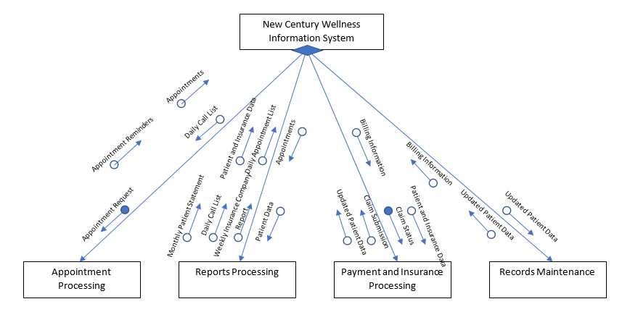

Figure 25: Diagram 1 Appointments Processing Module Structure Chart

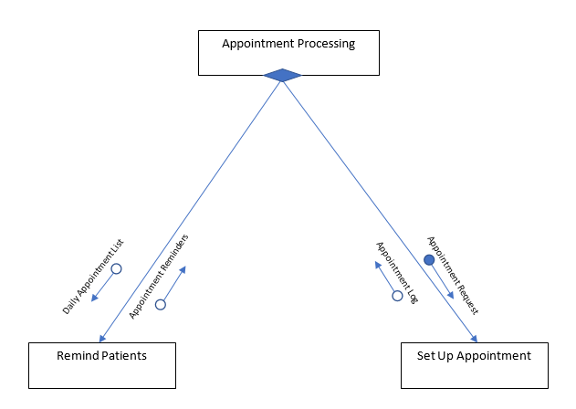

Figure 26: Diagram 2 Payment and Insurance Processing Structure Chart

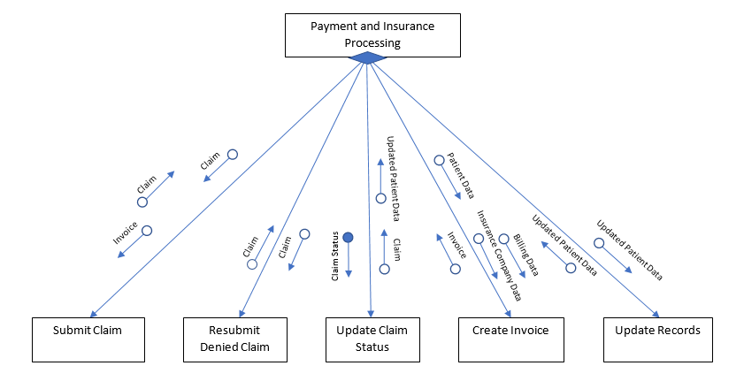

Figure 27: Diagram 3 Reports Processing Structure Chart

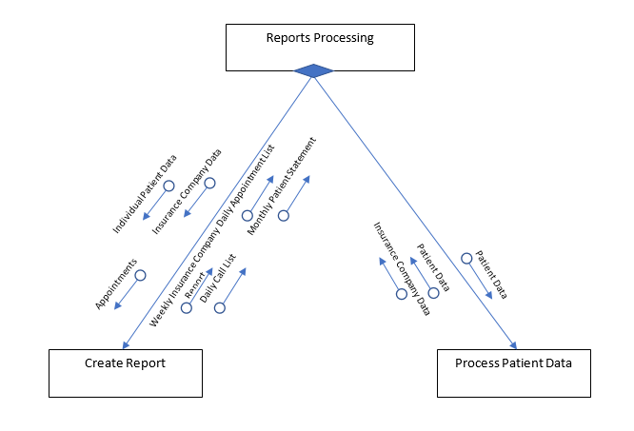

Figure 28: Diagram 4 Records Maintenance Structure Chart

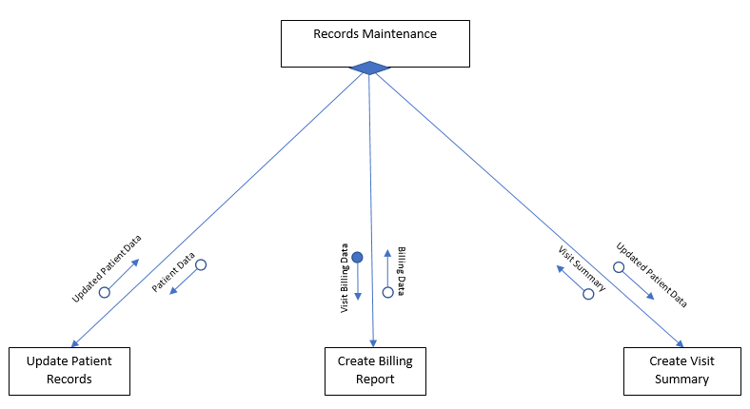

## Testing Plan

### Unit Testing

Unit testing tests whether the individual units of the program produce the required output. Each module, object, or method is tested to ensure that given erroneous data, the method detects it and does not proceed until the input is corrected.

The following data in Table 1 is example test data that will be used for the New Patient Entry Screen. The first row of data has valid data for all fields. Each subsequent row has an error in one of the fields. If the module for the New Patient Entry Screen is working correctly, it should validate each data field when the form is submitted with invalid data and generate an error asking the user to correct the data.

Table 20: Test Data for New Patient Entry Screen

|  |  |  |  |  |  |  |  |  |
| --- | --- | --- | --- | --- | --- | --- | --- | --- |
| **Error in Field:** | **First Name** | **Last Name** | **DOB** | **SSN** | **Street Address** | **City** | **State** | **Postal Code** |
| **None** | John | Doe | 10/28/1952 | 123-23-4567 | 57 Main St. | Allentown | PA | 19873 |
| **First Name** | 57J | Doe | 10/28/1952 | 123-23-4567 | 57 Main St. | Allentown | PA | 19873 |
| **Last Name** | John | n/a | 10/28/1952 | 123-23-4567 | 57 Main St. | Allentown | PA | 19873 |
| **DOB** | John | Doe | 10/28/1752 | 123-23-4567 | 57 Main St. | Allentown | PA | 19873 |
| **SSN** | John | Doe | 10/28/1952 | 123-23-456799 | 57 Main St. | Allentown | PA | 19873 |
| **Street Address** | John | Doe | 10/28/1952 | 123-23-4567 | Main St. | Allentown | PA | 19873 |
| **City** | John | Doe | 10/28/1952 | 123-23-4567 | 57 Main St. | A11entown | PA | 19873 |
| **State** | John | Doe | 10/28/1952 | 123-23-4567 | 57 Main St. | Allentown | Penn | 19873 |
| **Postal Code** | John | Doe | 10/28/1952 | 123-23-4567 | 57 Main St. | Allentown | PA | 75b39i |

### Integration Testing

After unit testing, each module of the system should be processing the data as intended and be able to catch erroneous data. The next step, integration testing, tests how the various modules of the system integrate with each other. An example would be whether the Set Up Appointment module in Diagram 0 of the data flow diagrams creates the correct data for the Appointments Data Store which will be used by the Reports Processing module.

Each module will be tested against every module that it interacts with as shown below. These tests will be based on the data flow diagrams that were created.

Table 21: Integration Testing Requirements

|  |  |  |  |  |
| --- | --- | --- | --- | --- |
| **Parent Module** | **Module to be Tested** | **Module Tested Against** | **Data Stores Involved** | **Pass/Fail** |
| Appointment Processing | Set Up Appointment | Reports Processing | Appointments |  |
| Remind Patients | Reports Processing |  |  |
| Payment and Insurance Processing | Submit Claim | Resubmit Denied Claim |  |  |
| Create Invoice |  |  |
| Resubmit Denied Claim | Submit Claim |  |  |
| Update Claim Status |  |  |
| Create Invoice | Submit Claim |  |  |
| Reports Processing |  |  |
| Records Maintenance |  |  |
| Update Claim Status | Resubmit Denied Claim |  |  |
| Update Records | Patients |  |
| Update Records | Update Claim Status | Patients |  |
| Records Maintenance |  |  |
| Reports Processing | Create Report | Process Patient Data | Patients, Insurance Companies |  |
| Appointment Processing | Appointments, Patients |  |
| Payment and Insurance Processing | Patients, Insurance Companies |  |
| Process Patient Data | Appointment Processing | Appointments, Patients |  |
| Payment and Insurance Processing | Insurance Companies, Patients |  |
| Payment and Insurance Processing | Create Report | Patients, Insurance Companies |  |
| Process Patient Data | Patients, Insurance Companies |  |
| Records Maintenance | Update Patient Records | Create Billing Report | Visit Summaries |  |
| Create Visit Summary | Visit Summaries |  |
| Create Billing Report | Update Patient Records | Visit Summaries |  |
| Patient and Insurance Processing |  |  |
| Create Visit Summary | Visit Summaries |  |
| Create Visit Summary | Create Billing Report | Visit Summaries |  |
| Update Patient Records | Visit Summaries |  |

### System Testing

Systems testing ensures that the entire system (software and hardware) works in a production environment. Systems testing involves user testing with live data. Systems testing also includes ensuring that users and IT staff have the proper documentation and training necessary to operate the system.

For the new system at New Century Wellness Center, systems testing will include all of the preceding components. After unit testing and integration testing is complete, a test environment including the entire system will be set up on a workstation. There will be a company-wide meeting explaining the new system as well as documentation that will be distributed. After the meeting, appointments will be set up for each employee where they will interact with the system using simulated data. Each employee will interact with the part of the system that relates to their job. While they are interacting with the system, the systems analyst will be monitoring their progress by watching over their shoulder as well as monitoring the system on their own laptop. After the interactive session, the employee will answer some questions and fill out a questionnaire and provide any additional feedback they feel is necessary.

## Training

Employees will need training on how to use the new system. The systems analyst as well as IT staff will provide the necessary training in a series of meetings. The first meeting will be a company-wide meeting that shows an overview of the system. Then there will be meetings for managers, office staff, nursing staff, and doctors pertaining to the part of the system they will be using. After that training is complete, employees will be able to set up individual meetings if they want additional clarification or have problems.

### Meeting 1:

Who: All Employees

Time: 2 Hours

Agenda:

Provide an overview of the new system, show a demonstration, and provide the rest of the training plan and schedule.

### Meeting 2:

Who: Managers

Time: 2 Hours

Training Agenda:

* Project origin and justification
* Cost-benefit analysis
* Support for business goals
* Documentation
  + Module Overview
  + Appointment Scheduling
  + Payment and Insurance Processing
  + Reports Processing
  + Records Maintenance
* IT Staff Responsibilities
* Office Staff Responsibilities
* Medical Staff Responsibilities

### Meeting 3:

Who: Office Staff

Time: 4 Hours

Training Agenda:

* System overview
* System documentation
* Major System Functions
* Appointments Processing
  + Set Up Appointments
  + Remind Patients
* Payment and Insurance Processing
  + Submit Claim
  + Resubmit Denied Claim
  + Update Claim Status
  + Create Invoice
  + Update Records
* Reports Processing
  + Create Report
  + Process Patient Data
* Records Maintenance
  + Create Billing Report
* Troubleshooting
* Frequently asked questions

### Meeting 4:

Who: Medical Staff

Time: 4 Hours

Training Agenda:

* System overview
* System documentation
* Records Maintenance
  + Create Visit Summary
  + Update Patient Records
* Appointment Processing
  + Set Up Appointment
* Troubleshooting guide
* Frequently asked questions

### Meeting 5:

Who: IT Staff

Time: 4 Hours

Training Agenda:

* Project history/justification
* System architecture
* System documentation
* Typical user questions
* Vendor support for outside provided systems
* Logging and resolving problems

### Additional Meetings as Needed

Who: TBD

Time: TBD

Agenda:

* Answer user questions as needed
* Go over training as needed
* Discuss how to resolve user problems
* Update system documentation and training manual as needed

# Appendix A: System Design Specification

## Management Summary

New Century Wellness Group is dedicated to serving the health needs of the surrounding community. In their effort to better serve their patients, they have decided to implement a new business software system that will allow them to more efficiently process appointments, patient and insurance data, and HR functions.

To date, I have

* Collected background information on New Century Wellness Group
* Researched various health information systems
* Prepared a preliminary investigation report
* Explained current project management concepts to management
* Created a joint application development (JAD) team to help design the new system
* Interviewed employees and created a questionnaire for patients to gather system requirements
* Performed data and process modeling for the new system
* Submitted a systems requirements document to management
* Prepared an overview of estimated system costs for various options as well as a cost-benefit analysis and economic feasibility studies
* Designed a user interface
* Determined the data requirements for the database
* And created the system architecture including a floor plan and hardware requirements

Currently, the system requirements have been gathered, and the new system has been designed. The next step is application development, followed by testing, implementation, user training and support.

The total cost of ownership for the new system over the next five years is estimated to be $51,600. This price includes:

* Consulting fees
* Networked commercial package
* Network and hardware installation
* Maintenance

The benefits of the new system are:

* Improved efficiency in the office
* Less errors than the current system
* Less need for overtime and additional staff
* More secure handling of patient and employee personal data

The system implementation schedule is as follows:

**Table 1: System Implementation Schedule**

|  |  |
| --- | --- |
| **Phase** | **Estimated Time** |
| Application Development | 4 weeks |
| Testing | 2 weeks |
| Implementation | 1 week |
| Training | 2 weeks |

Issues that may arise include security and training. The network needs to be internally and externally secure. Also, software and operational controls need to be in place to prevent unauthorized access to data. Training will take time out of everyone’s schedule. During the training phase, less patient appointments need to be scheduled because training will disrupt the normal schedule. However, training on the new system is very important so time needs to be set aside.

The system design specification below includes the system components, system environment, implementation requirements, and time and cost estimates.

## System Components

**User Interface**

**Figure 1: Main Screen Interface**



**Figure 2: Appointment Manager Interface**



**Figure 3: Payment and Insurance Processing Interface**



**Figure 4: Reports Processing Interface**



**Figure 5: Records Maintenance Interface**



**Sample Data Entry Form**

**Table 2: Data Fields**

|  |
| --- |
| Last Name |
| First Name |
| SSN |
| Gender |
| Marital Status |
| Address |
| City |
| State |
| Postal Code |
| Phone Number |
| Smoker |
| Alcohol |
| Drugs |
| Exercise |
| Medical Conditions |
| Allergies |
| Insurance Company |

**Figure 6: New Patient Entry Form**



**Control Features**

**Table 3: Example Control Features**

|  |  |  |
| --- | --- | --- |
| **Input** | **Control Features** | **Example** |
| Last Name | Text and dashes only  Check to see if name is already in system | Rivera-Martinez |
| Street Address | Number plus street name  Use map service to validate address | 123 Main St. |
| City | Text only | Lancaster |
| State | Dropdown of two character postal codes | PA |
| Zip Code | 5 digits plus 4 digits optional  Use map service to validate address | 17999 (+1234) |
| Telephone Number | Three-digit area code plus seven digit number | (929) 123-4567 |
| Insurance Company Name | Dropdown of list of insurance companies | Highmark |

**Possible Output Technologies that New Century Wellness Group Could Implement**

1. **Printed Reports**

Printed reports could include appointment lists for doctors, patient appointment call lists for the appointment manager, and monthly patient statements to be sent to patients. Printed reports are important for people who don’t have access to online systems or for certain office/medical staff applications.

1. **Internet Patient Portal**

An internet patient portal would be helpful for patients to schedule and view appointments, view medical records and view insurance and billing information.

1. **Email/Text Appointment Reminders**

Email and text appointment reminders would be a good way to remind patients of appointments that could be used in addition to the telephone reminder. Allowing patients to opt-in or opt-out will reduce the impression that New Century Wellness Group is spamming them.

1. **Internal Medical Records Portal for Doctors and Nurses**

Having medical records available in an online portal for doctors and nurses will be very helpful so that paper records are not lost or damaged.

1. **Internal Employee Benefits Portal**

An internal employee benefits portal will allow employees to view insurance, 401(k), and general HR information.



**Data and Process Modeling**

1. **Data Flow Diagrams**

**Figure 7: Data Flow Diagram – Context Diagram**



**Figure 8: Data Flow Diagram – Diagram 0**



**Figure 9: Diagram 1 – Appointment Processing**



**Figure 10: Diagram 2 – Payment and Insurance Processing**



**Figure 11: Diagram 3 – Reports Processing**



**Figure 12: Diagram 4 – Records Maintenance**



1. **Data Flows and Data Stores**

**Table 4: Data Flows and Data Stores**

|  |  |  |
| --- | --- | --- |
| **Data Flows** | **Data Stores** | **Data Elements** |
| Appointment Log | Appointments | Patient Name |
| Appointment Reminders | Date |
| Appointment Request | Time |
| Appointments | Doctor |
| Billing Data | Insurance Companies | Name |
| Claim Status | Services Covered |
| Daily Appointment List | Contact Information |
| Daily Call List | Patients | Name |
| Individual Patient Data | Telephone Number |
| Insurance Company Data | Insurance Information |
| Invoice | Visit Summaries | Patient Name |
| Monthly Patient Statement | Date |
| Patient Data | Time |
| Updated Patient Data | Services Performed |
| Visit Billing Data | Cost |
| Visit Summary |  |  |
| Weekly Insurance Company Report |  |  |

**Table 5: Dictionary Entry Example**

|  |  |
| --- | --- |
| **Label** | REMIND PATIENTS |
| **Entry Type** | PROCESS |
| **Description** | Remind patients of upcoming appointments |
| **Process #** | 0.1.1 |
| **Process Description** | Input data flows: DAILY APPOINTMENT LIST  Output data flows: APPOINTMENT REMINDERS  For each item on DAILY APPOINTMENT LIST  Call Patient Number  If Patient Answers  Remind Patient of Appointment  Else if answering machine  Leave a message  Else  Call back later |

1. **Object-Oriented Diagrams (not sure)**

**Table 6: Possible Use Cases for New Century Wellness Group**

|  |  |  |
| --- | --- | --- |
|  | **Use Case** | **Actor** |
| **1.** | Make New Appointment | Patient  Appointment Manager |
| **2.** | Remind Patient of Appointment | Appointment Manager  Patient |
| **3.** | Send Claim to Insurance Company | Insurance Billing Specialist  Insurance Company |

**Figure 13: Make New Appointment Use Case Diagram**



**Figure 14: Appointment Class Diagram**



**Figure 15: Appointment Sequence Diagram**



**Figure 16: State Transition States for Patient**



## System Environment

The system environment includes the conditions that the system is subject to. This includes the system architecture and physical and logical topologies. The system environment is the hardware, software and the users working together.

**System Architecture**

The system architecture shows the floor plan of the building with numbered rooms which correspond to the table below. The table shows the number of network nodes required in each room as well as the hardware needed in each room. Extra nodes have been allocated for future hardware requirements when the medical records system is implemented in Phase 2. The physical and logical network topologies are discussed as well as wireless networks.

1. Floor Plan

**Figure 17: Floor Plan for New Century Wellness Group**



**Table 7: Hardware and Network Requirements**

|  |  |  |  |  |
| --- | --- | --- | --- | --- |
| Room ID | Description | Equipment Currently Needed | Equipment Needed in the Future | Number of Ports |
| 1 | Exam Room 1 |  | Workstation or thin client | 3 |
| 2 | Exam Room 2 |  | Workstation or thin client | 3 |
| 3 | Exam Room 3 |  | Workstation or thin client | 3 |
| 4 | Exam Room 4 |  | Workstation or thin client | 3 |
| 5 | Medical Staff Cubicle Area | 1 Switch  10 workstations |  | 1 in  10 out |
| 6 | Office Staff Cubicle Area  (Extra cubicles for future expansion) | 1 Switch  8 Workstations |  | 1 in  10 out |
| 7 | Server/IT Equipment Room | 1 Gateway servers  2 Wireless Access Points  1 Wired Router |  | 1 cable/fiber port in  38 ports out |
| 8 | Nurse Station 1 | 1 Switch  3 Workstations  1 Laser Printer  1 Scanner |  | 1 in  3 out |
| 9 | Nurse Station 2 | 1 Switch  3 Workstations  1 Laser Printer  1 Scanner |  | 1 in  3 out |
| 10 | Nurse Station 3 | 1 Switch  3 Workstations  1 Laser Printer  1 Scanner |  | 1 in  3 out |
| 11 | Women’s Bathroom |  |  |  |
| 12 | Men’s Bathroom |  |  |  |
| 13 | Check-in/Check-out Station | 1 Switch  Possible Workstation (not specified)  1 Laser Printer  1 Impact Printer |  | 1 in  3 out |
| 14 | Waiting Area |  | Possible entertainment center | 1 |
| 15 | Supplies Room |  | Possible Inventory Control System | 1 |
| 16 | Exam Room 5 |  | Workstation or thin client | 3 |
| 17 | Exam Room 6 |  | Workstation or thin client | 3 |
| 18 | Exam Room 7 |  | Workstation or thin client | 3 |
| 19 | Exam Room 8 |  | Workstation or thin client | 3 |
| 20 | Exam Room 9 |  | Workstation or thin client | 3 |
| 21 | Exam Room 10 |  | Workstation or thin client | 3 |

1. Physical and Logical Network Topologies

Network topologies refer to the physical and logical structure of the network. A number of different logical topologies exist including hierarchical, bus, ring, star, and mesh networks, as well as wireless networks. The most common network today is the star topology using switches connected to network devices with ethernet cables. One ethernet cable connects one device (workstation or printer) to a switch. Switches can be daisy chained to reduce the amount of ethernet cabling needed. The advantage of using a star network is the degree of control. A disadvantage would be the outage that would occur when a switch went down. This can be mitigated with redundant switches.

It is recommended that New Century Wellness Group use the star topology with the following configuration.

The Internet gateway, servers, and main switch will be located in the Server/IT Equipment Room. A total of 38 ethernet cables will come out of the server room and be routed through the ceiling and down into the walls where there will be a wall mounted ethernet outlet.

Each exam room will have 3 ethernet connections. In the new system, there is no need for any connectivity in the exam rooms, but the electronic medical record phase of the project requires a workstation or thin client in each exam room. Adding 3 ethernet outlets for each exam room allows for connectivity for future medical equipment that may require network connectivity. Adding the extra cables now is negligibly more expensive compared to a high expense later. Also the supply room will have an ethernet outlet in case the room is repurposed in the future, or a networked inventory control system is added.

Each nursing station will have one ethernet cable going to it, and a 4 port ethernet switch installed to accommodate the 3 workstations. One of the workstations will have a laser printer and scanner installed locally so the printer and scanner will not require network connectivity.

The medical staff cubical area will have one ethernet cable going to it with a switch with at least 10 ports on it. More ports are preferred to accommodate future expansion. Again, having one ethernet cable connected to a switch reduces the cabling required from the Server/IT Equipment Room.

Likewise, the office cubical area will have the same configuration as the medical staff. However, there are only 8 workstations currently needed.

The check-in/check-out station will also have one ethernet cable with a switch to accommodate 2 networked printers and a possible workstation.

1. Wireless Network

A wireless network will be required in the future to accommodate the electronic medical records system which requires portable computers and tablets for the medical staff. Wireless networks are very useful for mobile devices, but can have connectivity issues for critical systems and have inherently less security than a wired network. If a wireless network is desired for guest access, it should be a separate system from the one for the electronic medical records system.

## Implementation Requirements

**Application Development Methods**

My team will use structured application development for the new system at New Century Wellness Center. Structured development will allow the system to be completely designed, coded and tested before deployment. This will allow us to make sure the system works and will keep the critical systems running at New Century Wellness that are currently in place.

The steps of structured application development are explained below.

1. Planning – The system has already been planned and designed. We used employee interviews, questionnaires and other ways to determine how the current system works, system requirements for the new system, and the database and hardware requirements. A new system has been designed that will meet the requirements of New Century Wellness Group.
2. Development – This phase will include coding the different modules needed for the new system. This includes design, code, test and documentation modules. The design will be based on the data flow diagrams that were developed previously.
3. Testing – Testing includes integration testing, system testing and documentation. Integration testing is taking the individual modules that were developed and making sure that they work well together. System testing is testing the entire system once it is installed and configured. That includes testing the hardware, the network and making sure all of the logical and physical components are doing their job. An example would be testing the printers to make sure the reports from the software are printing properly on the new network printers.

The system development tools that my team will use are explained below. These tools will help us design and develop a system that will meet the requirements of New Century Wellness Group.

1. Data Flow Diagrams – DFDs are a type of diagram that show how data flows to and from different entities and process in a system. The DFDs for the new system can be found in Section 4.5.
2. Entity-Relationship Diagrams – ER diagrams show relationships among the various entities and objects in the system. The relationship between entities and objects can be one-to-one, one-to-many, and many-to-many. An example of one-to-many is the relationship between one doctor and many patients. An example of a one-to-one relationship is the relationship between the office manager and the individual office staff members.
3. Flowcharts – Flowcharts are used to show program logic and rules in a graphical form. They help programmers break large processes down into smaller processes that can be programmed efficiently.
4. Pseudocode – Pseudocode is used to translate a primitive business function into simple English statements that represent programming steps. Pseudocode is a good intermediate between the design for the new system and the code that will be compiled into the new system.
5. Decision Tables and Decision Trees – These are used to show how business logic works in the new system. A decision tree shows the outcomes of a series of decisions. These helps to develop the system by making sure that all possible outcomes are designed into the system.

**Testing Plan**

**Unit Testing**

Unit testing tests whether the individual units of the program produce the required output. Each module, object, or method is tested to ensure that given erroneous data, the method detects it and does not proceed until the input is corrected.

The following data in Table 1 is example test data that will be used for the New Patient Entry Screen. The first row of data has valid data for all fields. Each subsequent row has an error in one of the fields. If the module for the New Patient Entry Screen is working correctly, it should validate each data field when the form is submitted with invalid data and generate an error asking the user to correct the data.

**Table 8: Test Data for New Patient Entry Screen**

|  |  |  |  |  |  |  |  |  |
| --- | --- | --- | --- | --- | --- | --- | --- | --- |
| **Error in Field:** | **First Name** | **Last Name** | **DOB** | **SSN** | **Street Address** | **City** | **State** | **Postal Code** |
| **None** | John | Doe | 10/28/1952 | 123-23-4567 | 57 Main St. | Allentown | PA | 19873 |
| **First Name** | 57J | Doe | 10/28/1952 | 123-23-4567 | 57 Main St. | Allentown | PA | 19873 |
| **Last Name** | John | n/a | 10/28/1952 | 123-23-4567 | 57 Main St. | Allentown | PA | 19873 |
| **DOB** | John | Doe | 10/28/1752 | 123-23-4567 | 57 Main St. | Allentown | PA | 19873 |
| **SSN** | John | Doe | 10/28/1952 | 123-23-456799 | 57 Main St. | Allentown | PA | 19873 |
| **Street Address** | John | Doe | 10/28/1952 | 123-23-4567 | Main St. | Allentown | PA | 19873 |
| **City** | John | Doe | 10/28/1952 | 123-23-4567 | 57 Main St. | A11entown | PA | 19873 |
| **State** | John | Doe | 10/28/1952 | 123-23-4567 | 57 Main St. | Allentown | Penn | 19873 |
| **Postal Code** | John | Doe | 10/28/1952 | 123-23-4567 | 57 Main St. | Allentown | PA | 75b39i |

**Integration Testing**

After unit testing, each module of the system should be processing the data as intended and be able to catch erroneous data. The next step, integration testing, tests how the various modules of the system integrate with each other. An example would be whether the Set Up Appointment module in Diagram 0 of the data flow diagrams creates the correct data for the Appointments Data Store which will be used by the Reports Processing module.

Each module will be tested against every module that it interacts with as shown below. These tests will be based on the data flow diagrams that were created.

**Table 9: Integration Testing Requirements**

|  |  |  |  |  |
| --- | --- | --- | --- | --- |
| **Parent Module** | **Module to be Tested** | **Module Tested Against** | **Data Stores Involved** | **Pass/Fail** |
| Appointment Processing | Set Up Appointment | Reports Processing | Appointments |  |
| Remind Patients | Reports Processing |  |  |
| Payment and Insurance Processing | Submit Claim | Resubmit Denied Claim |  |  |
| Create Invoice |  |  |
| Resubmit Denied Claim | Submit Claim |  |  |
| Update Claim Status |  |  |
| Create Invoice | Submit Claim |  |  |
| Reports Processing |  |  |
| Records Maintenance |  |  |
| Update Claim Status | Resubmit Denied Claim |  |  |
| Update Records | Patients |  |
| Update Records | Update Claim Status | Patients |  |
| Records Maintenance |  |  |
| Reports Processing | Create Report | Process Patient Data | Patients, Insurance Companies |  |
| Appointment Processing | Appointments, Patients |  |
| Payment and Insurance Processing | Patients, Insurance Companies |  |
| Process Patient Data | Appointment Processing | Appointments, Patients |  |
| Payment and Insurance Processing | Insurance Companies, Patients |  |
| Payment and Insurance Processing | Create Report | Patients, Insurance Companies |  |
| Process Patient Data | Patients, Insurance Companies |  |
| Records Maintenance | Update Patient Records | Create Billing Report | Visit Summaries |  |
| Create Visit Summary | Visit Summaries |  |
| Create Billing Report | Update Patient Records | Visit Summaries |  |
| Patient and Insurance Processing |  |  |
| Create Visit Summary | Visit Summaries |  |
| Create Visit Summary | Create Billing Report | Visit Summaries |  |
| Update Patient Records | Visit Summaries |  |

**System Testing**

Systems testing ensures that the entire system (software and hardware) works in a production environment. Systems testing involves user testing with live data. Systems testing also includes ensuring that users and IT staff have the proper documentation and training necessary to operate the system.

For the new system at New Century Wellness Center, systems testing will include all the preceding components. After unit testing and integration testing is complete, a test environment including the entire system will be set up on a workstation. There will be a company-wide meeting explaining the new system as well as documentation that will be distributed. After the meeting, appointments will be set up for each employee where they will interact with the system using simulated data. Each employee will interact with the part of the system that relates to their job. While they are interacting with the system, the systems analyst will be monitoring their progress by watching over their shoulder as well as monitoring the system on their own laptop. After the interactive session, the employee will answer some questions and fill out a questionnaire and provide any additional feedback they feel is necessary.

**Training**

Employees will need training on how to use the new system. The systems analyst as well as IT staff will provide the necessary training in a series of meetings. The first meeting will be a company-wide meeting that shows an overview of the system. Then there will be meetings for managers, office staff, nursing staff, and doctors pertaining to the part of the system they will be using. After that training is complete, employees will be able to set up individual meetings if they want additional clarification or have problems.

**Meeting 1:**

Who: All Employees

Time: 2 Hours

Agenda:

Provide an overview of the new system, show a demonstration, and provide the rest of the training plan and schedule.

**Meeting 2:**

Who: Managers

Time: 2 Hours

Training Agenda:

* Project origin and justification
* Cost-benefit analysis
* Support for business goals
* Documentation
  + Module Overview
  + Appointment Scheduling
  + Payment and Insurance Processing
  + Reports Processing
  + Records Maintenance
* IT Staff Responsibilities
* Office Staff Responsibilities
* Medical Staff Responsibilities

**Meeting 3:**

Who: Office Staff

Time: 4 Hours

Training Agenda:

* System overview
* System documentation
* Major System Functions
* Appointments Processing
  + Set Up Appointments
  + Remind Patients
* Payment and Insurance Processing
  + Submit Claim
  + Resubmit Denied Claim
  + Update Claim Status
  + Create Invoice
  + Update Records
* Reports Processing
  + Create Report
  + Process Patient Data
* Records Maintenance
  + Create Billing Report
* Troubleshooting
* Frequently asked questions

**Meeting 4:**

Who: Medical Staff

Time: 4 Hours

Training Agenda:

* System overview
* System documentation
* Records Maintenance
  + Create Visit Summary
  + Update Patient Records
* Appointment Processing
  + Set Up Appointment
* Troubleshooting guide
* Frequently asked questions

**Meeting 5:**

Who: IT Staff

Time: 4 Hours

Training Agenda:

* Project history/justification
* System architecture
* System documentation
* Typical user questions
* Vendor support for outside provided systems
* Logging and resolving problems

**Additional Meetings as Needed**

Who: TBD

Time: TBD

Agenda:

* Answer user questions as needed
* Go over training as needed
* Discuss how to resolve user problems
* Update system documentation and training manual as needed

## Time and Cost Estimates

**Costs**

1. **In-house Option**

The five-year cost of ownership to develop the new system in-house will be $51,600. That figure includes consulting fees, a networked commercial package, network and hardware installation, and ongoing maintenance.

**Table 10: Five Year Total Cost of Ownership for In-house Option**

|  |  |  |
| --- | --- | --- |
| In-house Option (1st year) | Consulting Fee (480 hours at $35/hour) | 16800 |
|  | Networked Commercial Package | 2500 |
|  | Network and Hardware Installation | 12500 |
|  | Ongoing Consulting Fee (120 hours) | 4200 |
|  | Cost of maintenance | 3120 |
|  | **Total** | **$39120** |
|  |  |  |
| Ongoing Costs (2nd year) | Cost of maintenance ($) | 3120 |
|  | **Total** | **$3120** |
|  |  |  |
| Ongoing Costs (3rd year) | Cost of maintenance ($) | 3120 |
|  | **Total** | **$3120** |
|  |  |  |
| Ongoing Costs (4th year) | Cost of maintenance ($) | 3120 |
|  | **Total** | **$3120** |
|  |  |  |
| Ongoing Costs (5th year) | Cost of maintenance ($) | 3120 |
|  | **Total** | **$3120** |
|  |  |  |
| Five Year Cost of Ownership |  | $51600 |

1. **Outsource Option**

The five-year cost of ownership to outsource the systems development will be $52,200. That figure also includes consulting fees, a vertical software package, network and hardware installation, ongoing maintenance, and technical support.

**Table 11: Five Year Total Cost of Ownership for Out-sourced Option**

|  |  |  |
| --- | --- | --- |
| In-house Option (1st year) | Consulting Fee (160 hours at $35/hour) | 5600 |
|  | Vertical Software Package | 4000 |
|  | Network and Hardware Installation | 12500 |
|  | Ongoing Consulting Fee (120 hours) | 4200 |
|  | Cost of maintenance | 3120 |
|  | **Total** | **$29420** |
|  |  |  |
| Ongoing Costs (2nd year) | Software Package Payment | 4000 |
|  | Cost of maintenance | 3120 |
|  | Technical Support Agreement | 600 |
|  | **Total** | **$7720** |
|  |  |  |
| Ongoing Costs (3rd year) | Software Package Payment | 4000 |
|  | Cost of maintenance | 3120 |
|  | Technical Support Agreement | 600 |
|  | **Total** | **$7720** |
|  |  |  |
| Ongoing Costs (4th year) | Cost of maintenance | 3120 |
|  | Technical Support Agreement | 600 |
|  | **Total** | **$3720** |
|  |  |  |
| Ongoing Costs (5th year) | Cost of maintenance | 3120 |
|  | Technical Support Agreement | 600 |
|  | **Total** | **$3720** |
|  |  |  |
| Five Year Cost of Ownership |  | **$51600** |

1. **Current Option**

The five-year cost of ownership to keep the current system at New Century Wellness Group is $195,000. That figure includes hiring a new office staff member, the cost of fixing errors, and the ongoing maintenance of the current system.

**Table 12: Five Year Total Cost of Ownership for Current Option**

|  |  |  |
| --- | --- | --- |
| In-house Option (1st year) | Cost of maintenance | 7020 |
|  | New Office Staff Member Cost | 15600 |
|  | Cost of errors | 3900 |
|  | **Total** | **$26520** |
|  |  |  |
| Ongoing Costs (2nd year) | Cost of maintenance | 7020 |
|  | New Office Staff Member Cost | 31200 |
|  | Cost of errors | 3900 |
|  | **Total** | **$42120** |
|  |  |  |
| Ongoing Costs (3rd year) | Cost of maintenance | 7020 |
|  | New Office Staff Member Cost | 31200 |
|  | Cost of errors | 3900 |
|  | **Total** | **$42120** |
|  |  |  |
| Ongoing Costs (4th year) | Cost of maintenance | 7020 |
|  | New Office Staff Member Cost | 31200 |
|  | Cost of errors | 3900 |
|  | **Total** | **$42120** |
|  |  |  |
| Ongoing Costs (5th year) | Cost of maintenance | 7020 |
|  | New Office Staff Member Cost | 31200 |
|  | Cost of errors | 3900 |
|  | **Total** | **$42120** |
|  |  |  |
| Five Year Cost of Ownership |  | **$195000** |

1. **Benefits**
   1. **In-house Option**

The benefits of developing a software system in-house include the ability to customize the software to the exact requirements of New Century Wellness Group, not having to pay a technical support fee every year, and a slight decrease from the cost of out-sourcing. A disadvantage of developing a new system in-house is that it may take more time than what an outsourced system would be.

* 1. **Outsource Option**

The benefits of outsourcing the development of the new system include ongoing technical support, less headache in designing the system and peace of mind that comes from a system that is already being used by similar companies. A disadvantage of outsourcing is that the system may not be as customizable as a system developed in-house.

* 1. **Current Option**

There are not many benefits to keeping the current system. Having to add another office staff person adds a significant cost as well as the cost of correcting errors and significantly higher maintenance costs than what would be needed for the new system.

* 1. **Table of Benefits for In-House or Outsource Option**

**Table 13: Benefit Types**

|  |  |  |
| --- | --- | --- |
| **Benefit** | **Type** | **Benefit Amount** |
| Not having to hire new employee | Cost-avoidance | $140,400 (4.5 years) |
| Growth Benefit | Postive | $15,000 (5 years) |
| **Total** | | **$155,400** |

**Table 14: Benefit Yearly Amounts**

|  |  |  |  |  |  |
| --- | --- | --- | --- | --- | --- |
| **Benefit** | **Year 1** | **Year 2** | **Year 3** | **Year 4** | **Year 5** |
| Not having to hire new employee | $15,600 | $31,200 | $31,200 | $31,200 | $31,200 |
| Growth Benefit | $3000 | $3000 | $3000 | $3000 | $3000 |
| Total | $18,600 | $34,200 | $34,200 | $34,200 | $34,200 |

1. **Cost Benefit Types and Categories**
   1. **Maintenance Costs –** Costs to maintain the systems so that they function properly.
   2. **Consulting Fees –** Fees to consulting firm to oversee the systems analysis, design, and implementation phases.
   3. **Software Purchase -**Costs to purchase and implement software packages.
   4. **Network and Equipment Upgrades –** Costs to upgrade network and server equipment to support and host the new software systems. Newer hardware is more secure and faster than current hardware.
   5. **Personnel Requirements –** Costs to hire new office staff member to support current system if no change is made to the system.
   6. **Ongoing Costs –** Costs of technical support and maintenance that will ensure continued optimal functioning of the systems.

### Economic Feasibility Analysis

1. **Payback Analysis**

**Figure 17: Payback Analysis**

1. **Return on Investment**

**Table 15: Return on Investment (ROI)**

|  |  |  |  |
| --- | --- | --- | --- |
| **Option** | **Total Cost** | **Total Benefit** | **Return on Investment (ROI)** |
| In-House | $51,600 | $155,400 | 201% |
| Outsourced | $52,300 | $155,400 | 197% |

1. **Present Value**

**Table 16: Present Value for In-House Option**

|  |  |  |  |  |  |  |
| --- | --- | --- | --- | --- | --- | --- |
|  | **Year 0** | **Year 1** | **Year 2** | **Year 3** | **Year 4** | **Total** |
| **Benefits** | 18600 | 34200 | 34200 | 34200 | 34200 |  |
| **Factor** | 0.909 | 0.826 | 0.751 | 0.683 | 0.621 |  |
| **PV of Benefits** | 16907 | 28249 | 25684 | 23359 | 21238 | $115,438 |
|  |  |  |  |  |  |  |
| **Costs** | 39120 | 3120 | 3120 | 3120 | 3120 |  |
| **Factor** | 0.909 | 0.826 | 0.751 | 0.683 | 0.621 |  |
| **PV of Costs** | 35560 | 2577 | 2343 | 2131 | 1938 | $44,549 |
|  |  |  |  |  |  |  |
|  |  |  | **Net Present Value** | | | **$70,889** |

**Table 17: Present Value for Out-Sourced Option**

|  |  |  |  |  |  |  |
| --- | --- | --- | --- | --- | --- | --- |
|  | **Year 0** | **Year 1** | **Year 2** | **Year 3** | **Year 4** |  |
| **Benefits** | 18600 | 34200 | 34200 | 34200 | 34200 |  |
| **Factor** | 0.909 | 0.826 | 0.751 | 0.683 | 0.621 |  |
| **PV of Benefits** | 16907 | 28249 | 25684 | 23359 | 21238 | $115,438 |
|  |  |  |  |  |  |  |
| **Costs** | 29420 | 7720 | 7720 | 3720 | 3720 |  |
| **Factor** | 0.909 | 0.826 | 0.751 | 0.683 | 0.621 |  |
| **PV of Costs** | 26743 | 6377 | 5798 | 2541 | 2310 | $43,768 |
|  |  |  |  |  |  |  |
|  |  |  | **Net Present Value** | | | **$71,670** |

# Appendix B: System Maintenance Issues

After systems implementation, several issues have been identified. Users have reported poor system performance during peak usage. Additionally, users have requested fixes, enhancements, and additional features. Security is also a serious concern. These issues have been addressed in a series of memos.

New Century Wellness Group

123 Green Lane

California 98383

## System Performance Memorandum

TO: New Century Wellness Group Staff

FROM: Randy Petersheim, Systems Analyst

DATE: April 22, 2017

SUBJECT: System Performance Issues

Thank you for reaching out to me regarding the recent system performance issues. Performance can be measured in many ways, but the most common include response time, bandwidth, throughput and turnaround time. Performance is very important because users want the system to respond instantaneously to their requests. Any lag causes the users to lose momentum in the job they are trying to do which costs companies money and makes users unhappy.

* 1. *Response time* is the time it takes for a system to deliver the expected output once the user provides the input. An example would be the time it takes for the results to appear on the screen when someone types a search term into Google. Response time measures the performance of many individual components and the integration of those components.
  2. *Bandwidth* is measured in bits per second and is the amount of data that a system can process or deliver in a set amount of time.
  3. *Throughput* is like bandwidth, but measures the bandwidth when it is affected by real world factors such as heavy network loads or hardware parameters.
  4. *Turnaround time* is like response time, but measure the time it takes for a system to deliver a batch request like payroll processing. It can also be used to measure the time it takes for an entity such as an IT department to respond to a user ticket.

We will have the system analyzed to identify why the response time is so slow. However, it is likely that the slow response time at New Century Wellness Group is due to an inadequate data server as well as some inefficiencies in the new software system. It is recommended that the data server be upgraded to accommodate the increased amount of data requests. Also, the current version of the software will be analyzed to see if any improvements can be made to increase system performance.

New Century Wellness Group

123 Green Lane

California 98383

## Ongoing Maintenance Memorandum

TO: New Century Wellness Group Staff

FROM: Randy Petersheim, Systems Analyst

DATE: April 22, 2017

SUBJECT: Ongoing Maintenance and Release Methodology Memo

Thank you for contacting me regarding ongoing maintenance for the new business system at New Century Wellness Group. I am happy to assist with any ongoing maintenance issues. For software systems, there are four basic types of maintenance: corrective, adaptive, perfective and preventative maintenance.

1. *Corrective Maintenance* is responding to errors and problems in a system that is already being used in production. Problems are usually brought to the attention of IT by users submitting a ticket to have something fixed or changed. Most IT departments have standard forms that users can go to and describe their problem and submit it.
   1. An example of corrective maintenance is that a user cannot access an internal webpage that they are supposed to have access to. IT needs to set the correct permissions so that the employee can do their job.
   2. A printer stops working so IT needs to replace or repair the printer in a timely manner.
2. *Adaptive maintenance* is when new features or enhancements are added to a system.
   1. An example is when a chemical company employee wants to be able to sort a list of chemicals according to supplier. If the feature does not exist, IT can add the feature to the existing system.
   2. Another example is when IT has a form for corrective maintenance tickets, but upper management wants them to add a separate form for adaptive maintenance projects.
3. *Perfective maintenance* is taking a system that meets user requirements and making it better. Better could mean faster, more user friendly, or more maintainable.
   1. An example of perfective maintenance a marketing department that wants to add some responsive design elements to an existing website to make the website more attractive.
   2. Another example would be taking a program that allows sales managers to generate monthly reports on most popular products and making the program more efficient so that it does not take up so much system resources.
4. *Preventative maintenance* is taking steps to avoid problems down the road. A good analogy is changing the oil in your car to keep the engine from wearing down prematurely.
   1. An example of preventative maintenance is updating the operating systems on workstations so that they are more secure.
   2. Another example is analyzing a database for faulty data and taking steps to correct the issue that is causing the faulty data.

One of your additional concerns is the several requests for enhancements and noncritical changes that have been submitted by users. Those types of request fall under adaptive maintenance. Those changes will be addressed and updated in the system according to an adaptive maintenance release methodology. Release methodology is releasing updates at reasonable intervals. If an update is critical to security or data integrity, it will be released right away. If an update is not critical, it is saved and a bunch of updates are compiled and updated at once at a date agreed upon by New Century Wellness Center. Release methodology helps to control the system in production. The release cycle for New Century Wellness Group will be once a month. As the number of requests decreases over time as the system becomes perfected, the release cycle will be increased.

New Century Wellness Group

123 Green Lane

California 98383

## Security Risks Memorandum

TO: New Century Wellness Group Staff

FROM: Randy Petersheim, Systems Analyst

DATE: April 22, 2017

SUBJECT: System Security and Risk Management

I have some concerns about the security of the information system at New Century Wellness Group. You may have noticed the incident in the local news where an area man was disgruntled at his employer and threatened to steal his company’s data. While I’m sure that would never happen at New Century Wellness Group, I have realized that we did not give enough thought to security when we designed the new business system and would like to take steps to manage the security risks for the new system.

Risk management is the process of identifying risks, assessing their priority and taking steps to control the risks. Identifying risks means identifying company assets, and then for each asset identifying the risks to that asset. For example, an asset could be a data server and some of the risks could include hacking, data corruption, or physical damage. Once the risks are identified for each asset, the risks are individually assessed by assigning an impact value and a vulnerability rating. The impact value is the cost to the company if the asset is lost, and the vulnerability rating is the likelihood of the asset being lost. Multiplying those two numbers results in the risk assessment. Risk control is taking steps to mitigate the risk. An example of mitigating the risk to the data server could be putting the server behind a firewall, having two servers so that data is not lost if it is corrupted, and having the data backed up offsite.

The main risks that I have identified at New Century Wellness Group are as follows:

|  |  |
| --- | --- |
| **Risk to Information System** | **Risk Control Recommendation** |
| Unauthorized access from outside the company network through the Internet | Install a firewall to limit the type of traffic that is allowed through the gateway |
| Unauthorized access to employee and patient data from within the network | Require employees to lock out their workstations when leaving their desks, and have them update their workstation passwords once a month. This can be accomplished by changing settings on the server to automatically notify employees to change their password. |
| Data corruption or physical damage to data server | Use a third-party cloud service to back up data server on a continuous basis. |

The once the risks identified above are mitigated according to the recommendations, the likelihood of data theft or loss can be lowered significantly. It should be noted that the employee and patient data is the most sensitive part of the system that needs to be protected on a continuous basis.